Project “Improving skills in laboratory practice for agro-food specialists in eastern Europe” (Ag-Lab)
Program Erasmus+, project KA2 n° 586383-EPP-1-2017-1-SI-EPPKA2-CBHE-JP (2017-2978/001-001)
Report on participant in training session
Dates: 07.09.2019 – 05.10.2019
Place: University of Lubliana, Slovenia.
The study visit had the practical character, classes were conducted in laboratories of veterinary and biotechnical faculties of Ljubljan University, farms, in the center of insemination, the beekeeping center.
Taking into account the complexity of the subject the training was English or in Slovenian with the translation into English.
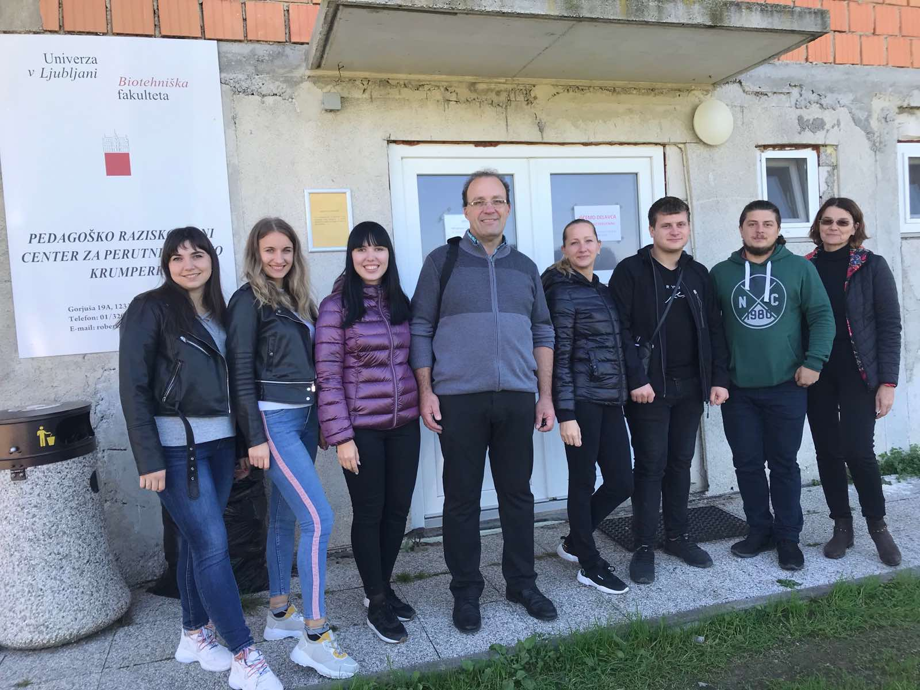

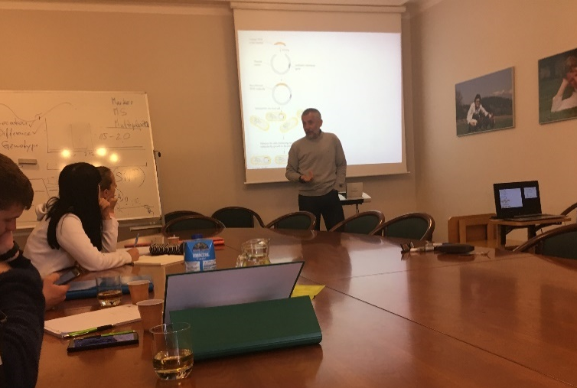
09.09.2019 - Our working day began at 9:00 am in the Department of Animal Science of the Biotechnical Faculty. Professor Petr Dovc gave us a lecture on the basics of genetics, structure and DNA coding.

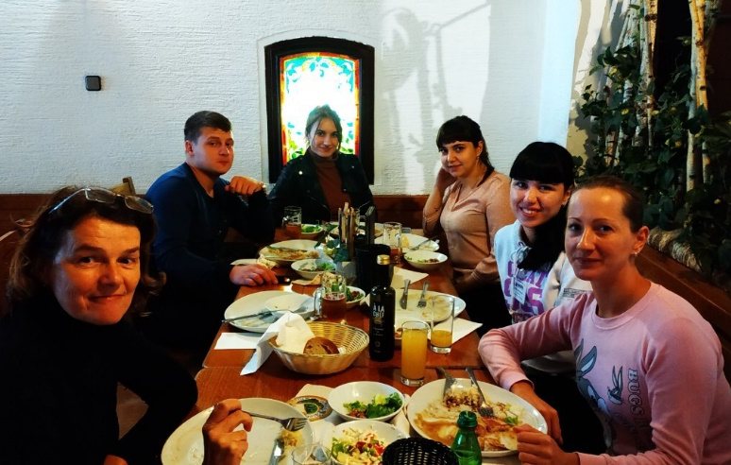
For lunch we went with Maria Klopcic and student from Moldova to restaurant Adam Rawbar. There we tasted national Slovenian cuisine.

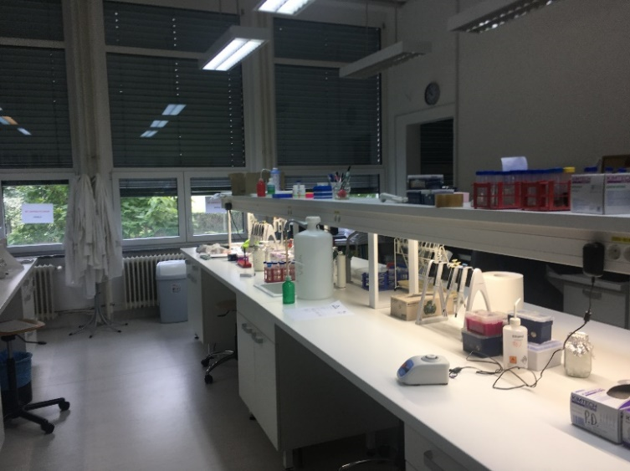
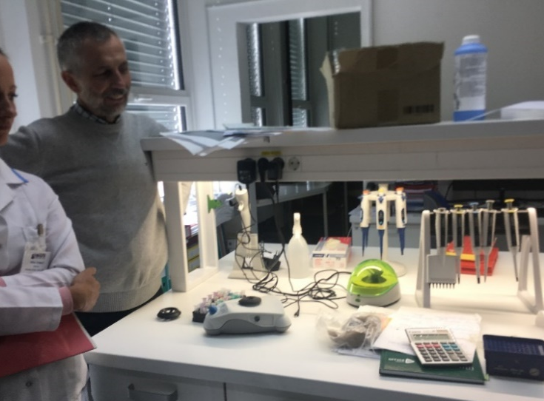
After lunch break we visited the Genetic Research Laboratory at the Biotechnical Faculty. In the laboratory we got acquainted with the devices by which the PCR is performed.
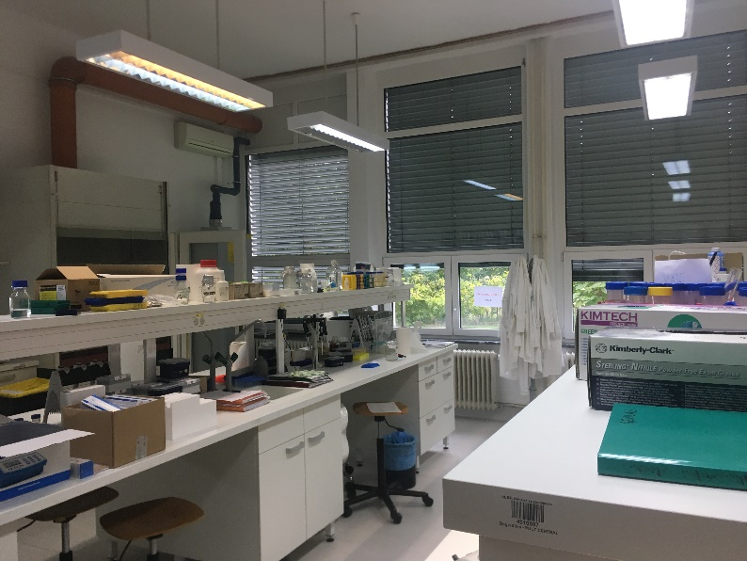
10.09.2019 - We listened to the lecturer Peter Dovc long about a Polymerase Chain Reaction. The lectures were presented as PCR methods (real-time method and agarose gel electrophoresis method), phase stages and its scope. After the lecture, we went to the genetic laboratory again and more presented the PCR in real time.
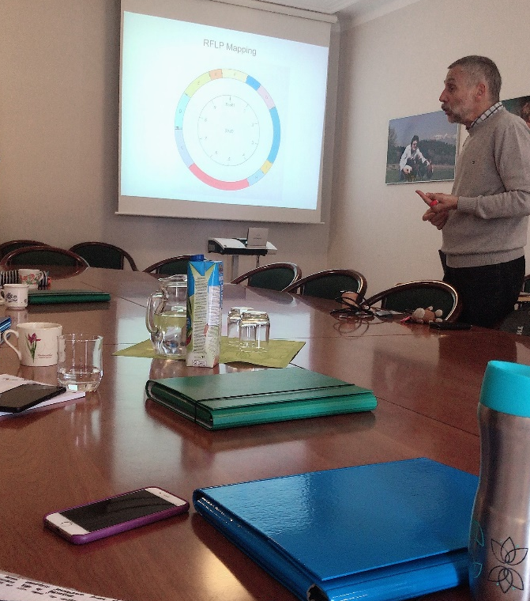
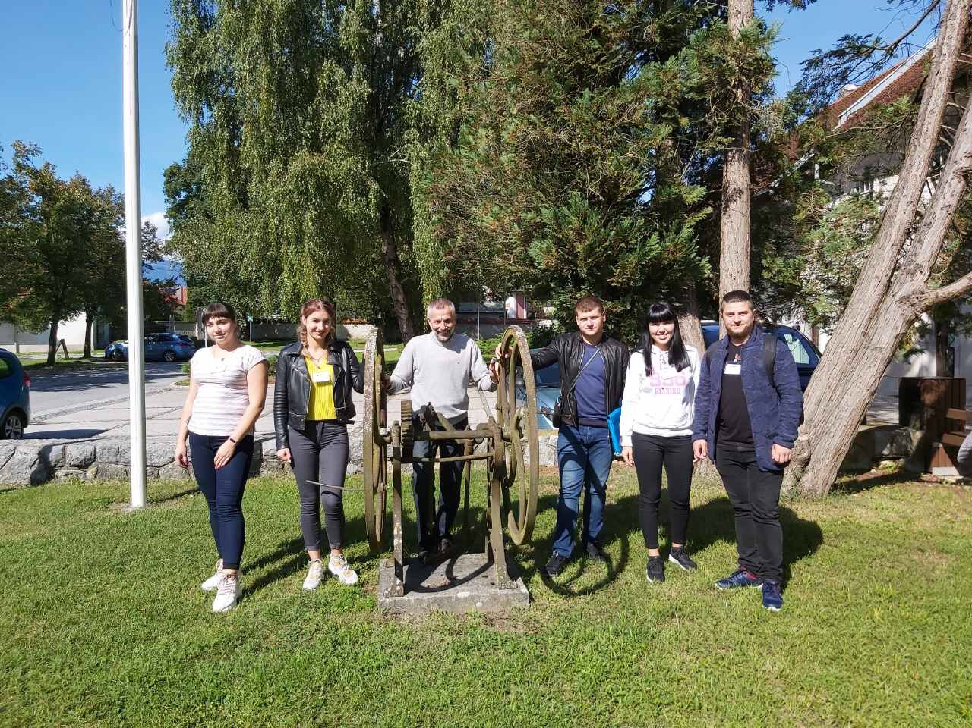
At the end of the day, we and Moldavian students took a photo with a professor.

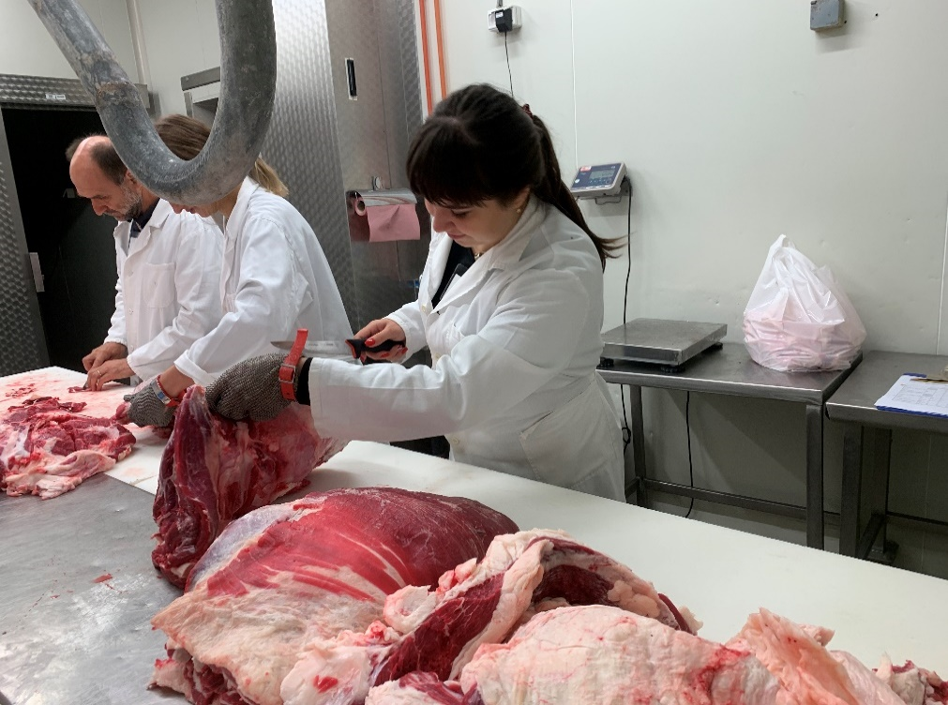
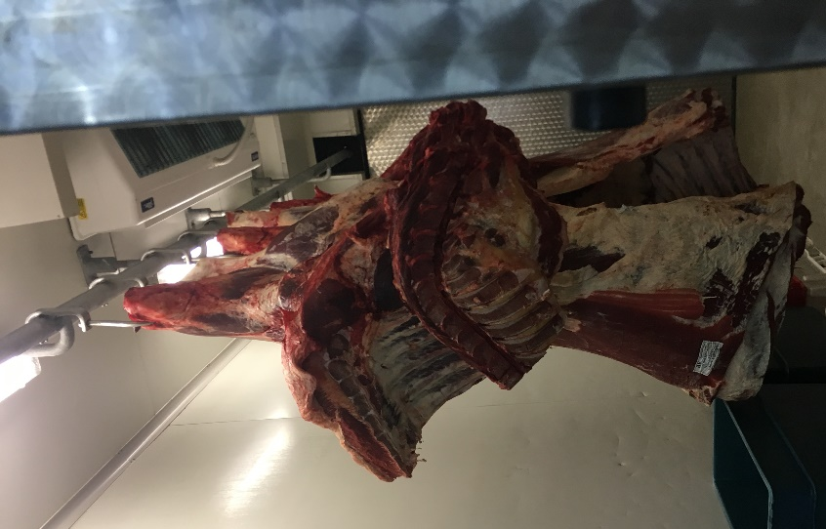
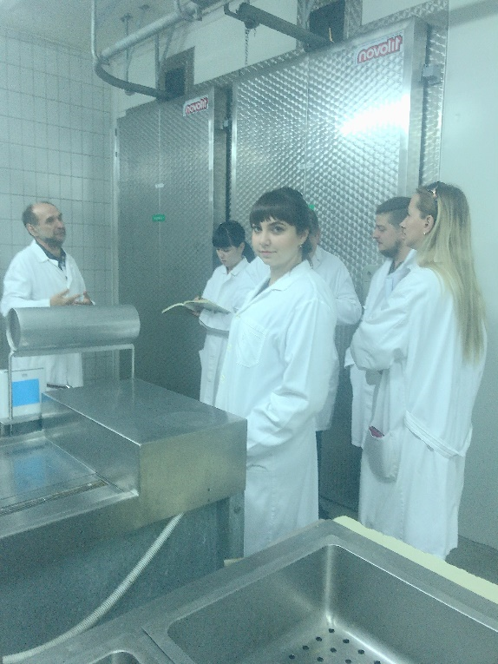
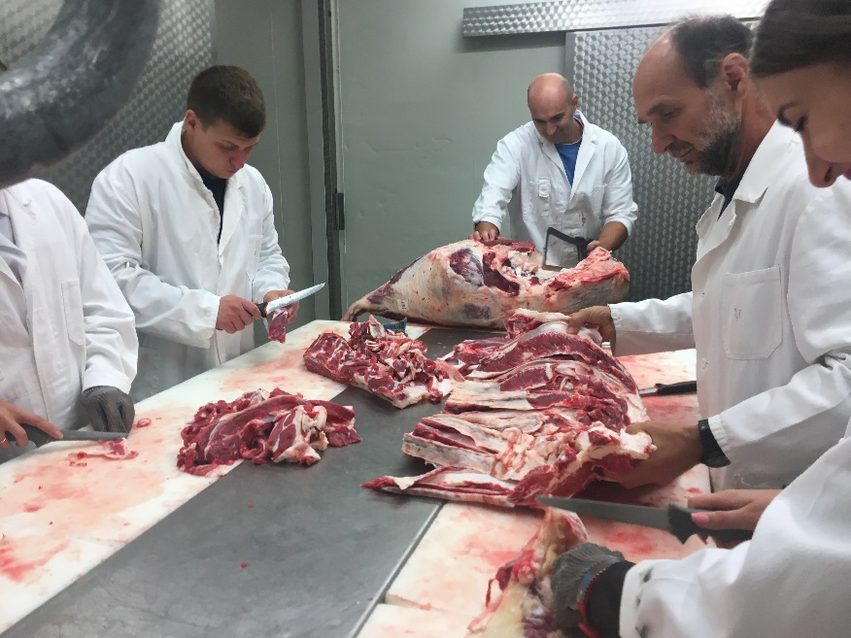
11.09.2019 - We spent that day in a practice workshop in a slaughterhouse. Professor Silvo Zgur held us a tour of the slaughterhouse and told that the equipment is carried out by a particular operation. We studied commodity cuts of beef. We used to disassemble the carcass of the bull by ourselves, separate the fat from the meat. Also, calculating the number of bones, fat, meat in the bull's carcass.

12.09.2019 - We started our day at 9:00. Professor Silvo Zgur read a lecture on the estimate of meat quality. We learned:
- About chemical processes in meat passing during his maturation;
- About the quality of assembly of meat quality in different European countries;
- About the characteristics of the meat for which evaluate the quality: colour, aroma, smell, juiciness, flavour, tenderness, leanness, texture;
- We also learned about the process of glycolysis and its impact on the quality of meat.
Also, the professor spoke about methods of laboratory evaluation of meat quality.
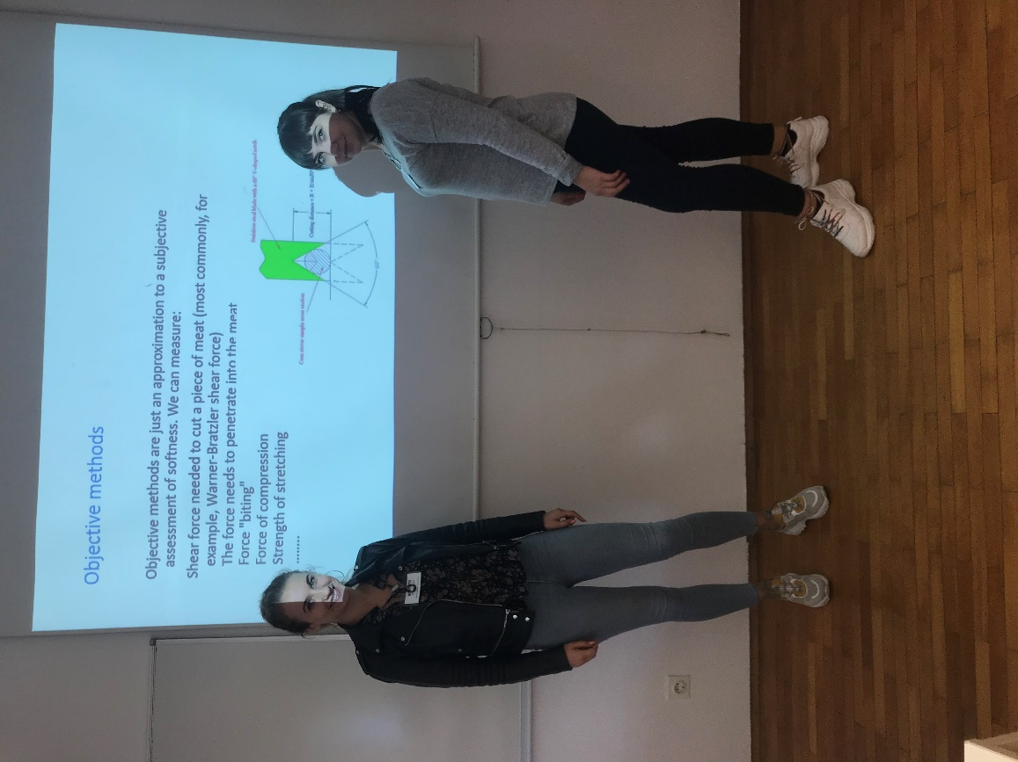

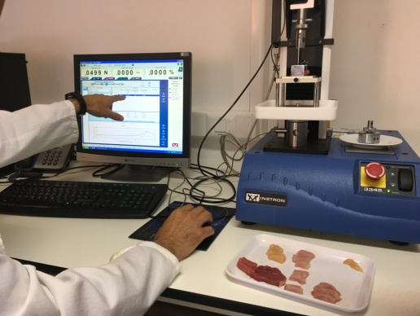
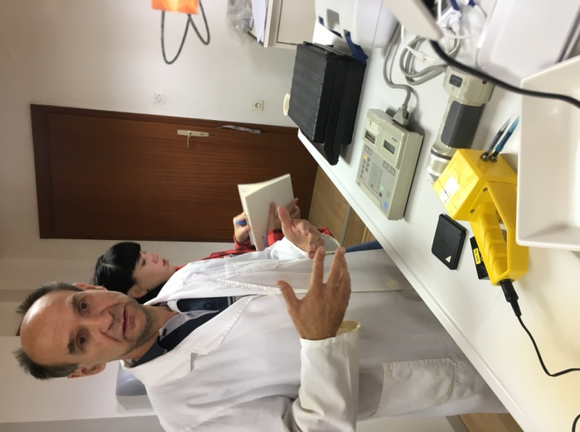
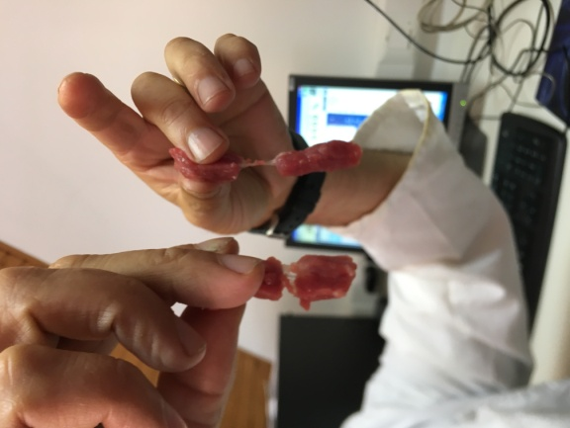
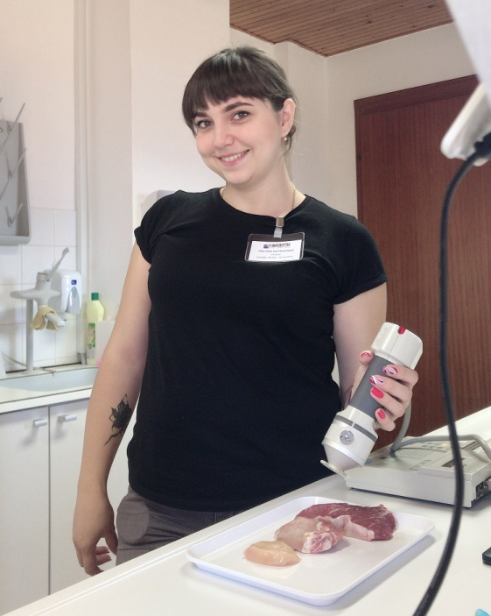
13.09.2019 – Our working day began at 9:00. We worked in one of the laboratories of the Biotechnical Faculty. We have been evaluated to quality of turkey, chicken, pork, and beef. Pork and beef were two samples: Semi tenginosus and Longisimus, turkey and chicken - Brist. In estimating quality, we measured pH, the colour was determined using a spectrophotometer, estimated the rigidity of meat on the Instron 3345 device. The etching tissue was carried out with different temperatures of the journey. Still, we had the opportunity to observe the process of oxygenization, after every 5 minutes we measured the colour and followed the change in the indicators.
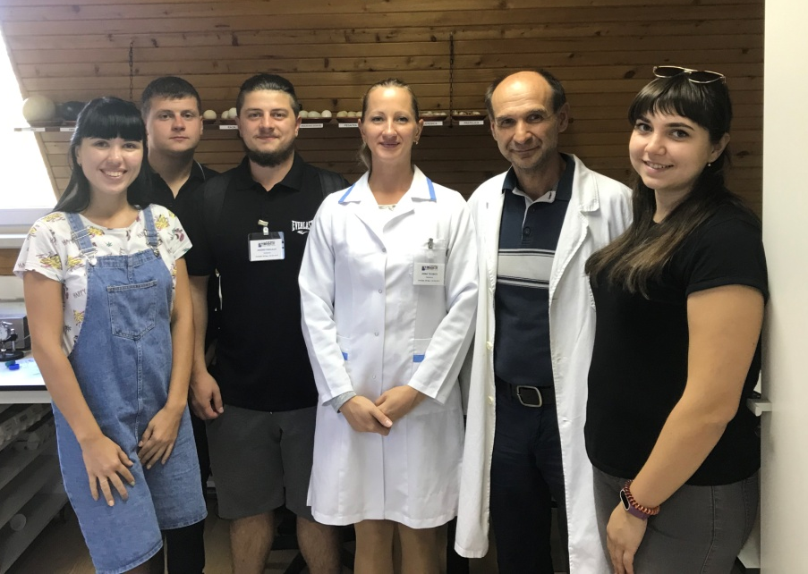
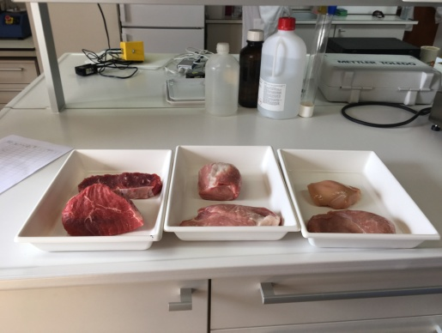
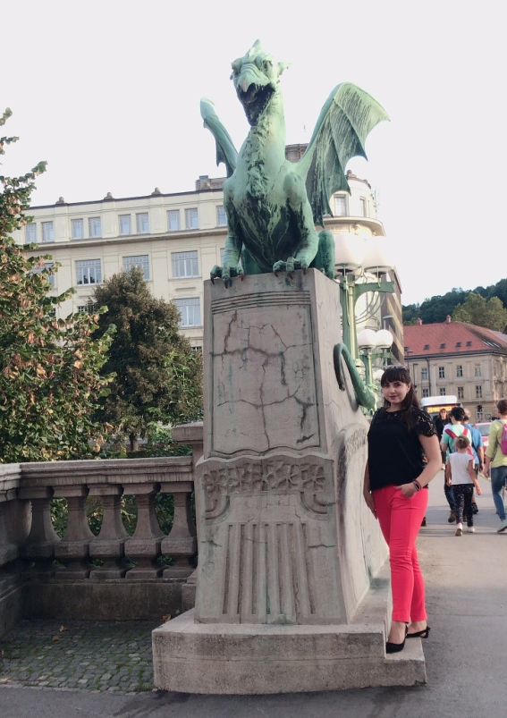
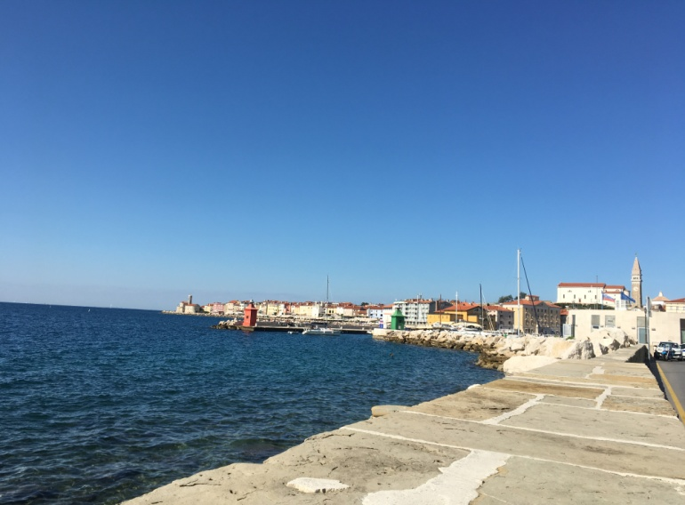
14-15.09.2019 - Our weekend has gone very bright. On Saturday we went to Ljubljana. Here we visited most prominent places: Three bridges and the main square, Ljubliana castle, Dragon's bridge, the center of modern culture - Metelkova Art Center.
On Sunday we went to the picturesque city of Piran. All day we spent on the shore of the Adriatic Sea - bathing and tanned.
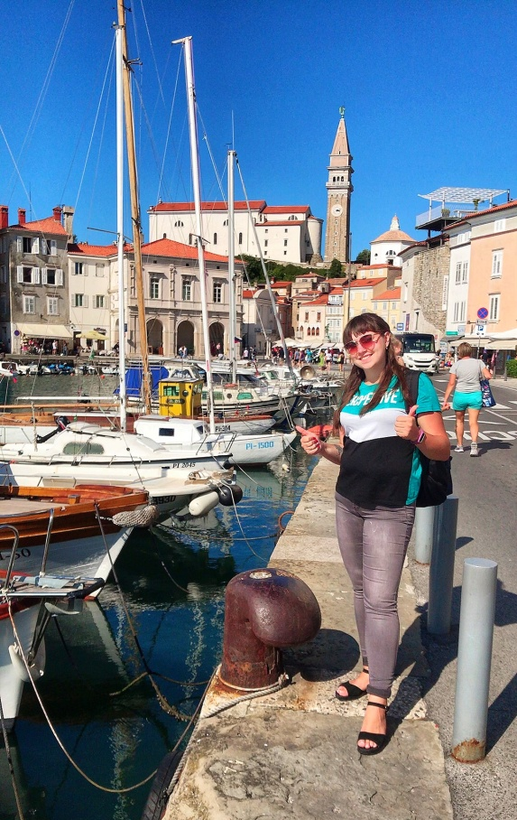
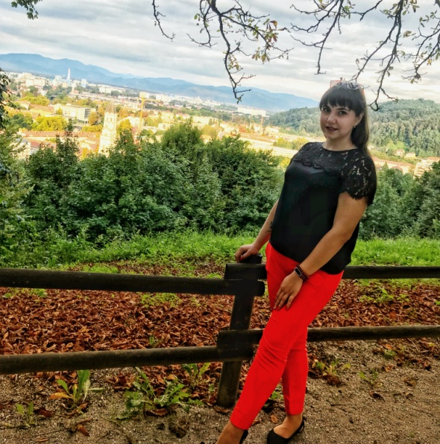
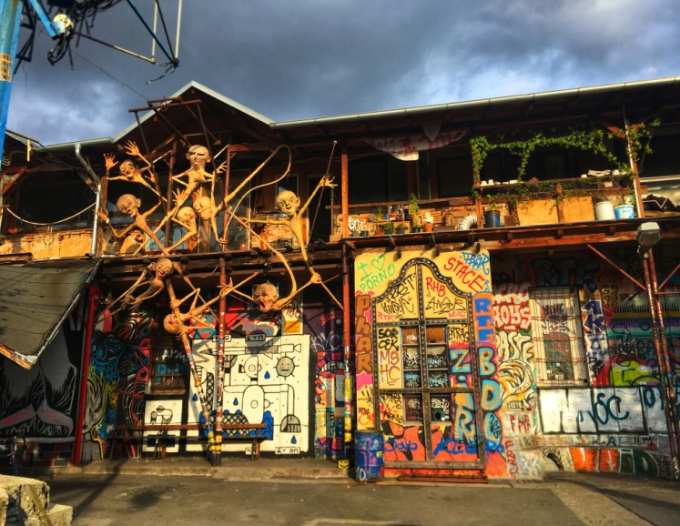
16.09.2019 - Today we worked in the genetic laboratory of professor Petr Dovc under the guidance of his assistant Tine. We were sampling for PCR, namely measuring the concentration of turtle DNA in the samples being tested. And than those samples in which it is the highest were selected for reaction. For the study we have selected 25 samples from 258.
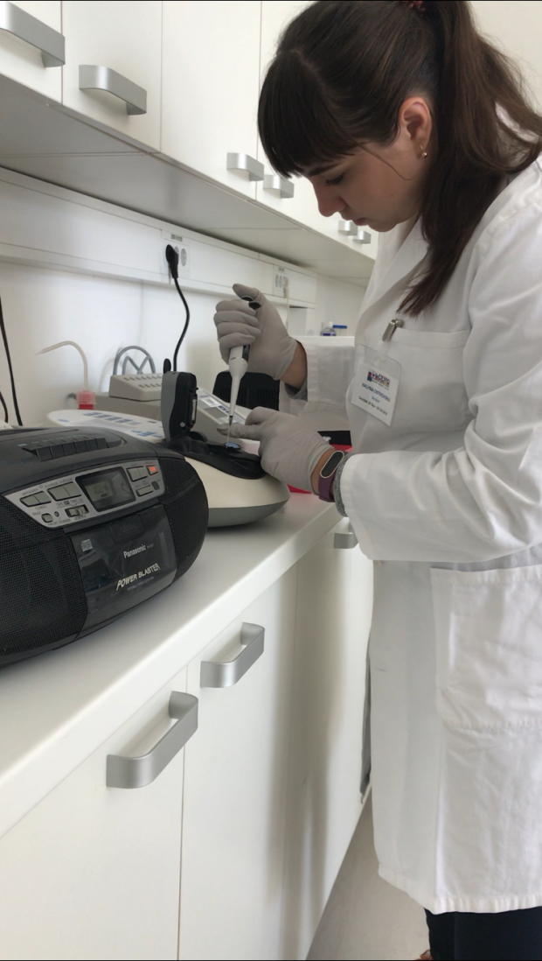
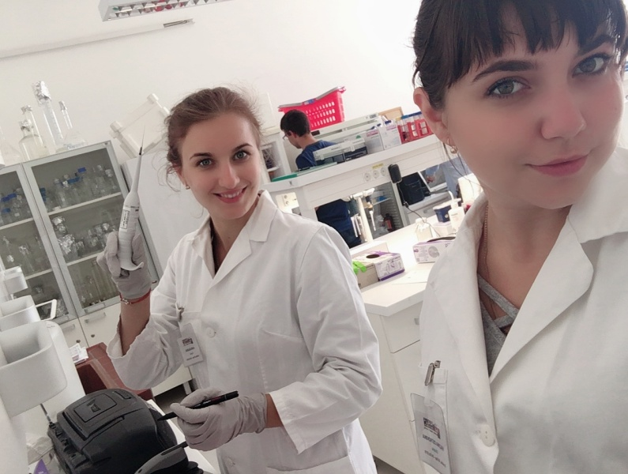

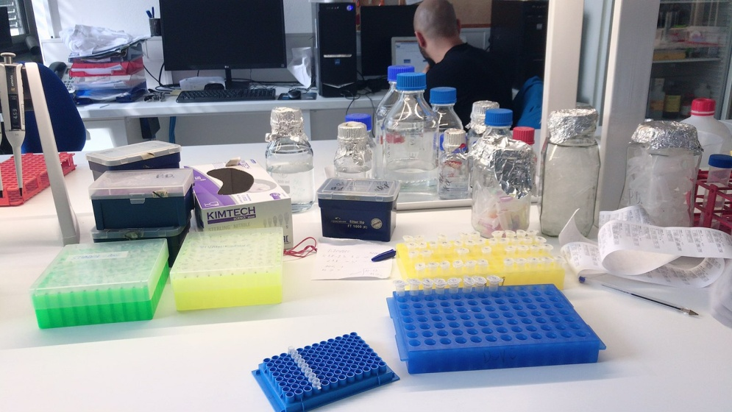
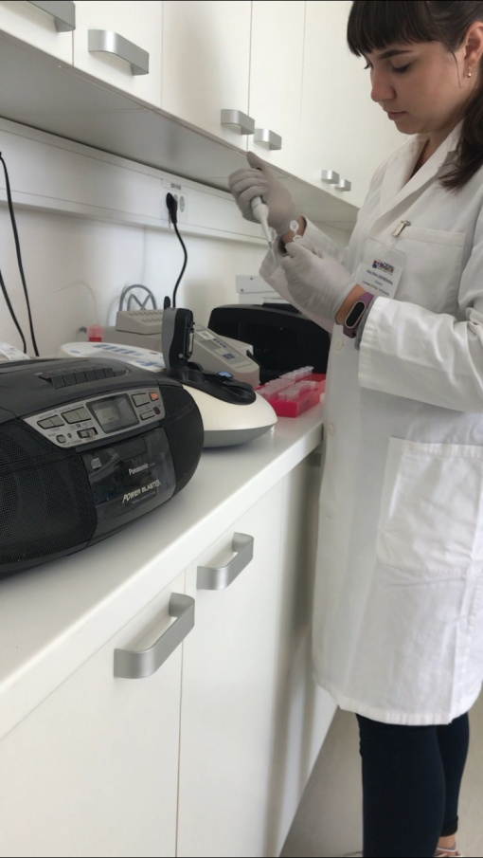

17.09.2019 - Today, our classes were again practical. Together with Marija Klopcic we visited four farms. On all farms we measured the microclimate parameters of livestock premises: wind speed, light, temperature, humidity. We measured the same metrics outside of them. We also measured the temperature of the compost on the first two farms. The first was a farm in Logatec.
The educational research centre (PRC) Logatec has operated within the Department of Animal Science of the Biotechnical Faculty in Ljubljana since 1977, when the Centre for Beef Cattle was established in Logatec. With the construction of stabling for performance testing of rams in 1982, the activity of the Centre was also extended to sheep meat production systems. The current educational research centre in Logatec performs important activities in the field of breeding beef cattle, sheep and goats.
Stock animals: the average number amounts to around 220 beef cattle of various categories and age and 250 rams of various breeds
Breeding herd:
- Charolais: 35 cows, 20 heifers, 1-2 sires for natural breeding
- Limousine: 35 cows, 20 heifers, 1-2 sires for natural breeding
Performance test stationt: 20 bulls of Charolais and 20 Limousin breeds, 250 rams of various breeds.
Then we went to three family farms.
Family farm HOČEVAR JANEZ, Zapoge
New barn with compost bedding pack barn: 70 Holstein cows and 70 Young stock/
Family farm DAMJAN ZORE? Zgornje Pirniče, Medvode. Dairy farm with Holstein cows in Free Barn with cubicles: 75 Holstein cows and 75 Young stock
Family farm MATJAŽ KAJZAR, Dvor 4, LJUBLJANA. Family farm with suckler cows Simmental + Crossing.
7 Simmental cows + 20 calves Simmental breed or Crossing with Beef breeds (Limousin, Charolaies, Blue Belgiesh).

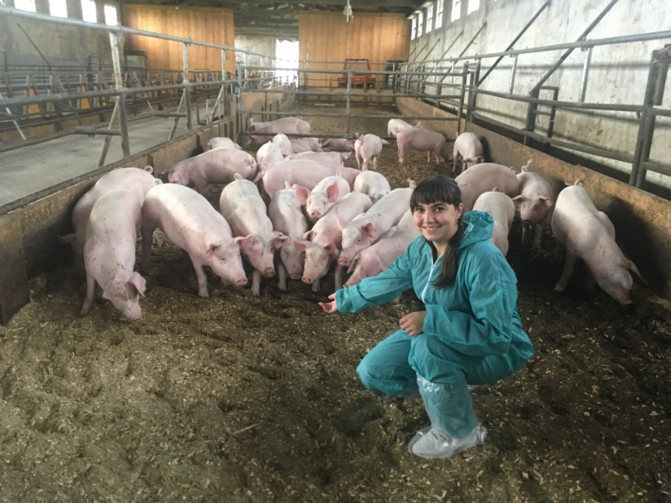
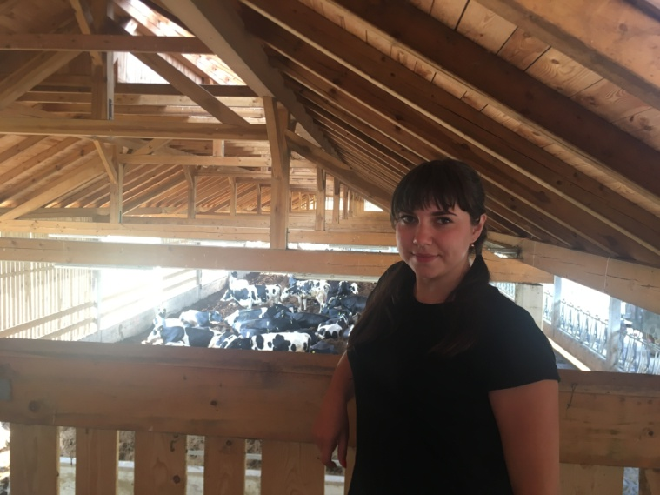
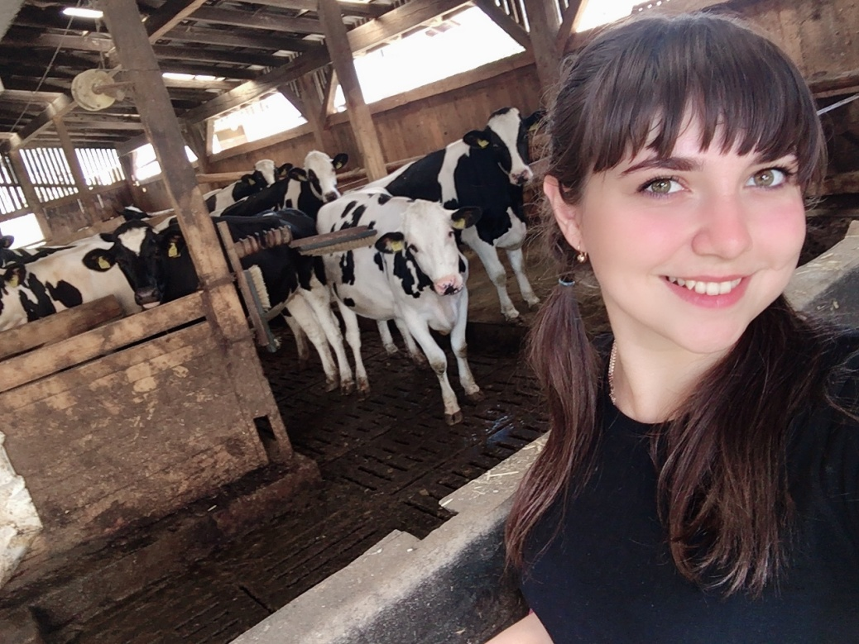
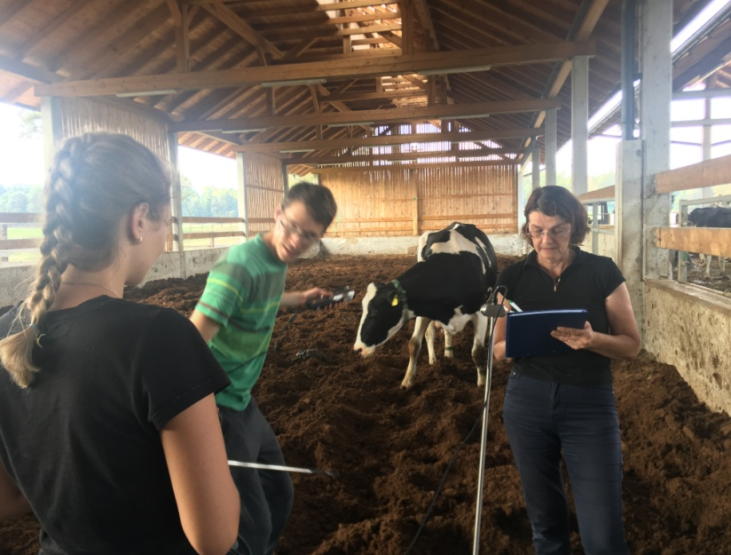
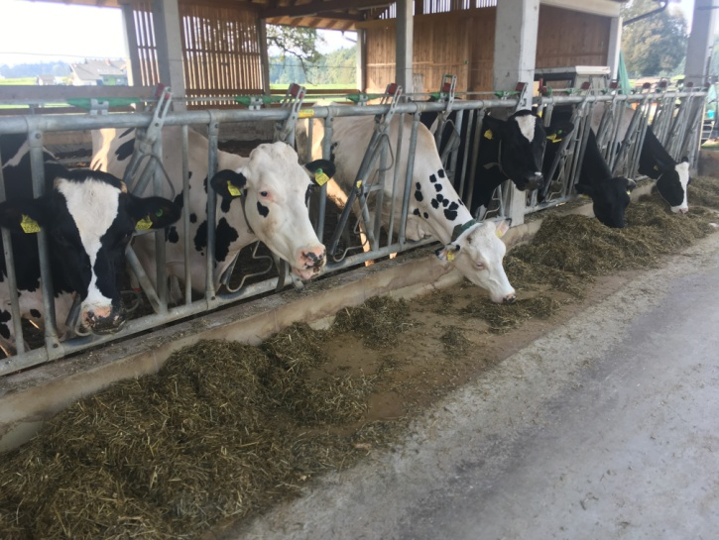

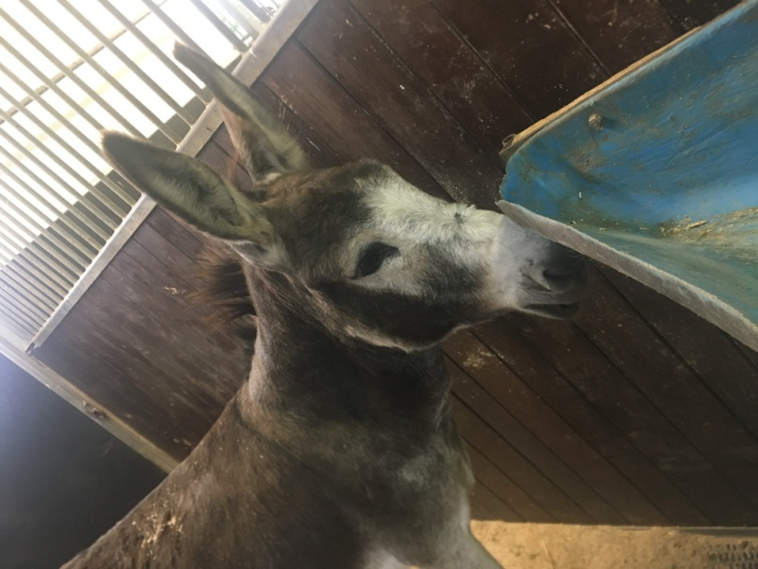
18.09.2019 - Today we visited the laboratories of the veterinary faculty of the University of Ljubljana. Professor Jože Starič gave us an excursion to the veterinary clinic of small and large animals, the laboratory for clinical studies of various diseases, and the mastita laboratory. Magda Nemec introduced us to the method of blood analysis for the presence of antibodies. Faculty laboratories are equipped with modern equipment. The clinics also have modern equipment, operating and postoperative wards.
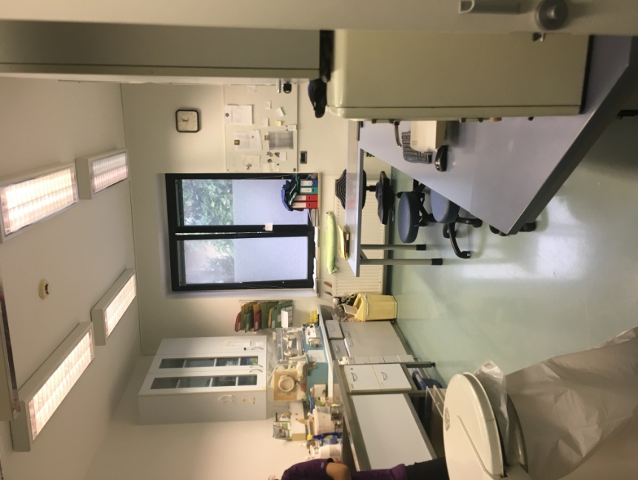
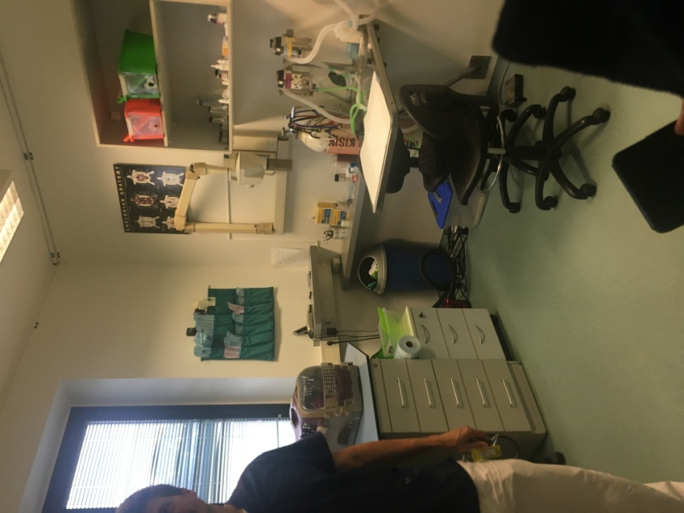
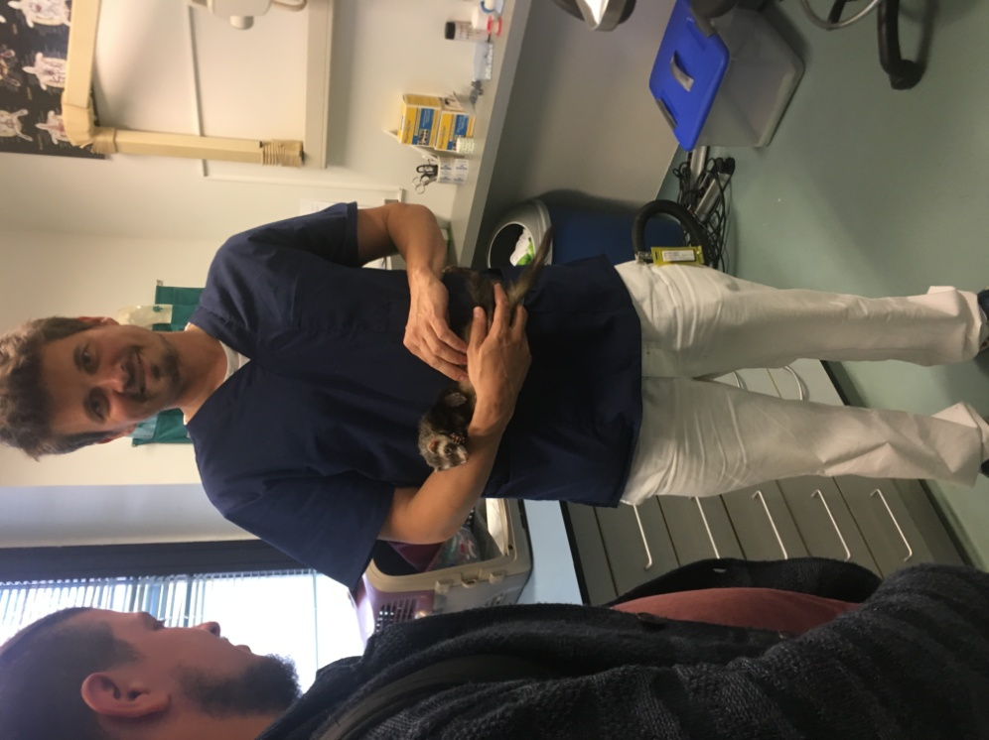

19.09.2019 - Today we had a very productive and interesting day. We were in the center of insemination. Our work day started at 7:00. We saw the entire workflow of the center from start to finish: semen collection, semen analysis, packaging, cooling and freezing. We also tried to do all these processes ourselves.
In the Insemination Center Preska strictly follow professional standards and legal requirements for processing, storage and distribution of semen. The semen is only acquired from bulls that have a high genetic value and meet the specified health conditions. During the processing of semen monitory the cell count in the ejaculate, the semen is inspected microscopically, an agent that enables survival of spermatozoa during freezing and thawing is added, and in the final phase, the semen is preserved by freezing it with liquid nitrogen at the temperature of -196°C. Final product is an insemination dose with at least 20 million of spermatozoa with proper motility.
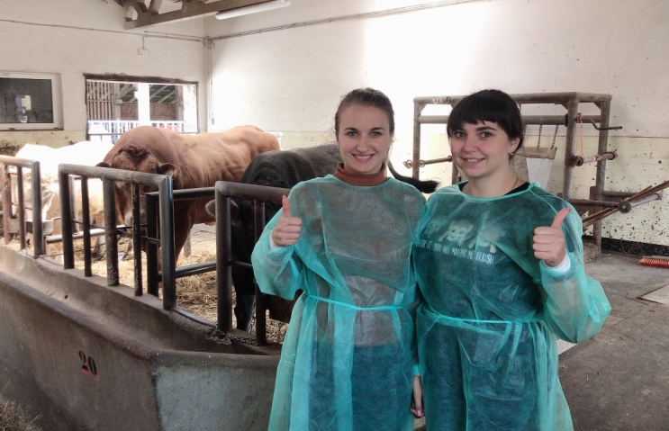
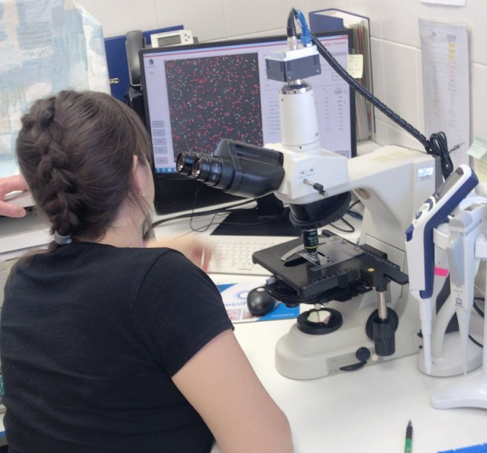

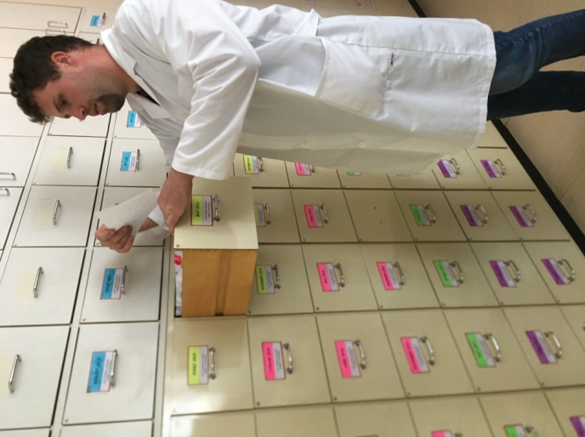
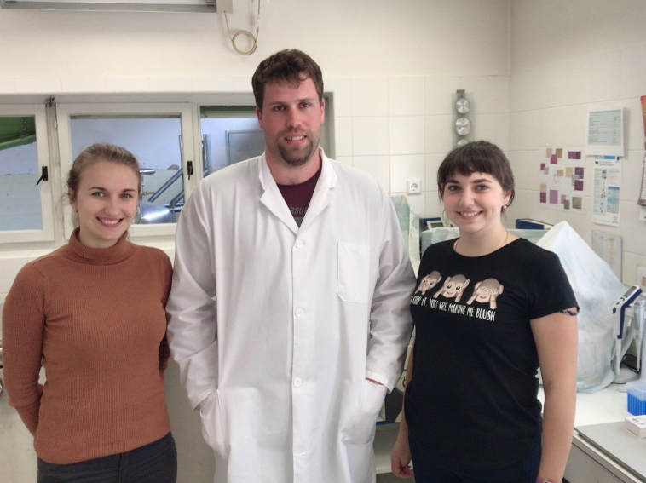
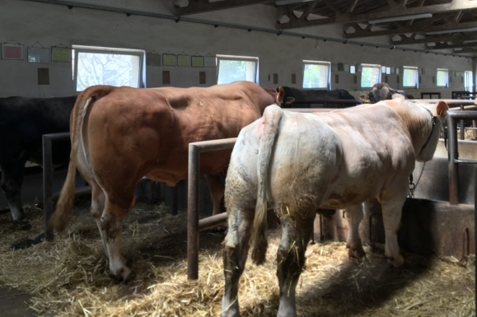

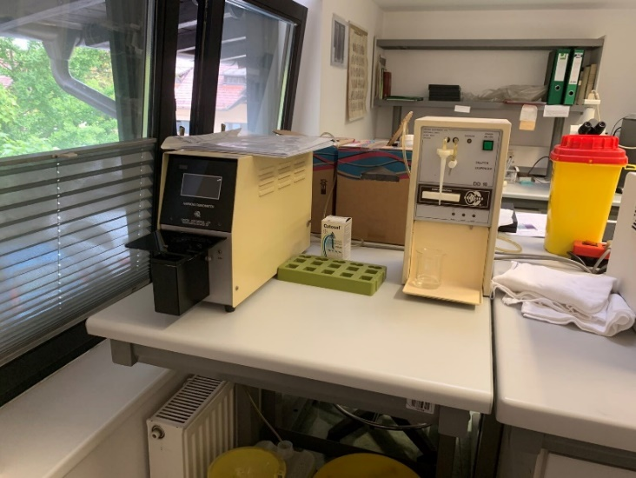
20.09.2019 - Today we again worked in the laboratory of the Veterinary Faculty. Together with Magda Nemec, we studied the blood of parrots, horses and guinea pigs for antibodies. After that we visited the library of the veterinary faculty. This was very useful for us, because there we found a lot of useful literature to help us in our specialty work.

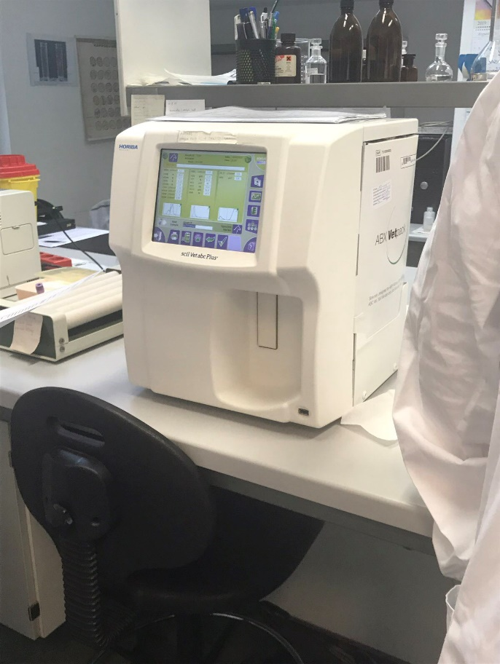

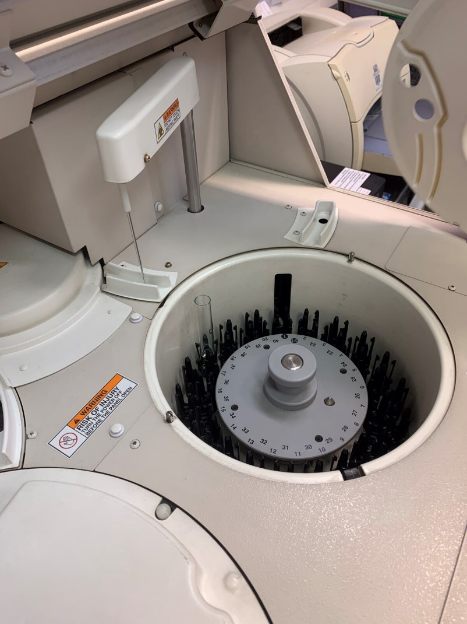

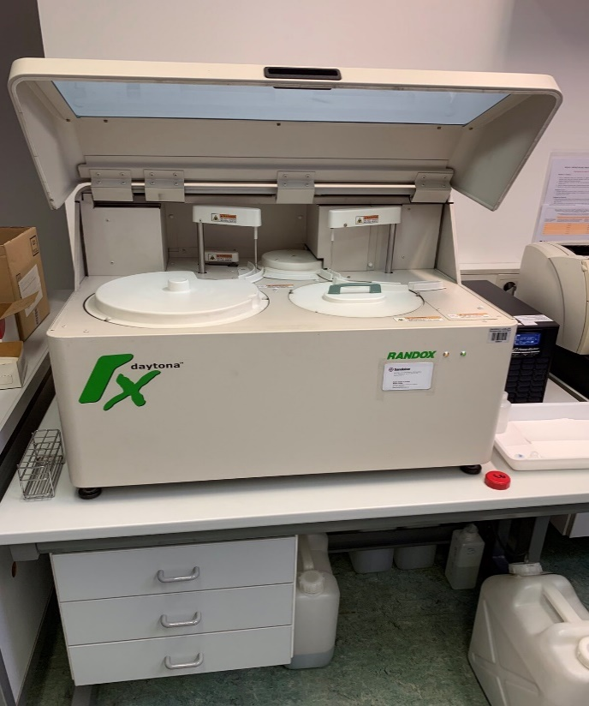

21.09.2019 - Again, our weekend began with impressions. Today we went to Lake Bled. We really enjoyed our mini-trip. I had never seen such beauty before. We climbed the fortress by the lake, took lots of photos. After that, we went to a cafe with Maria and the Moldovan students, where we tasted Kremshnit's signature dessert.
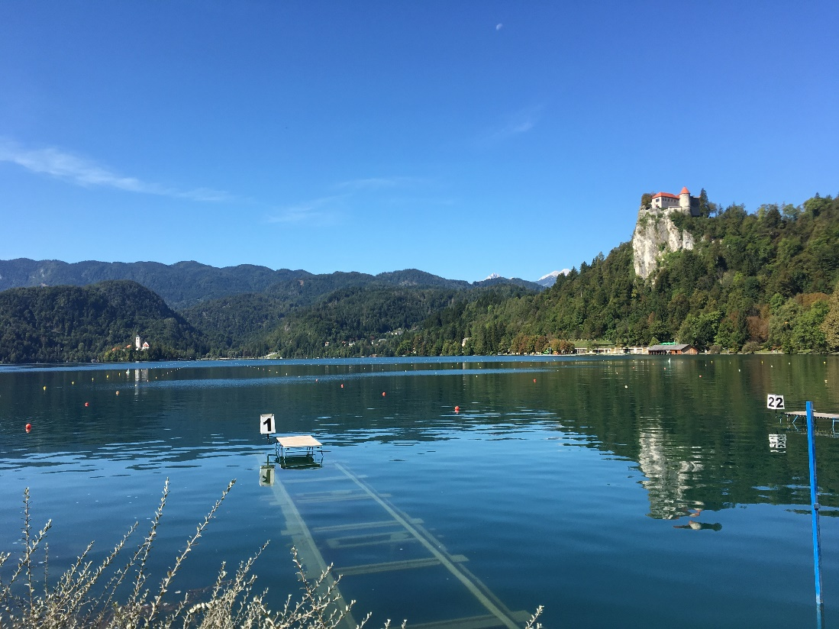

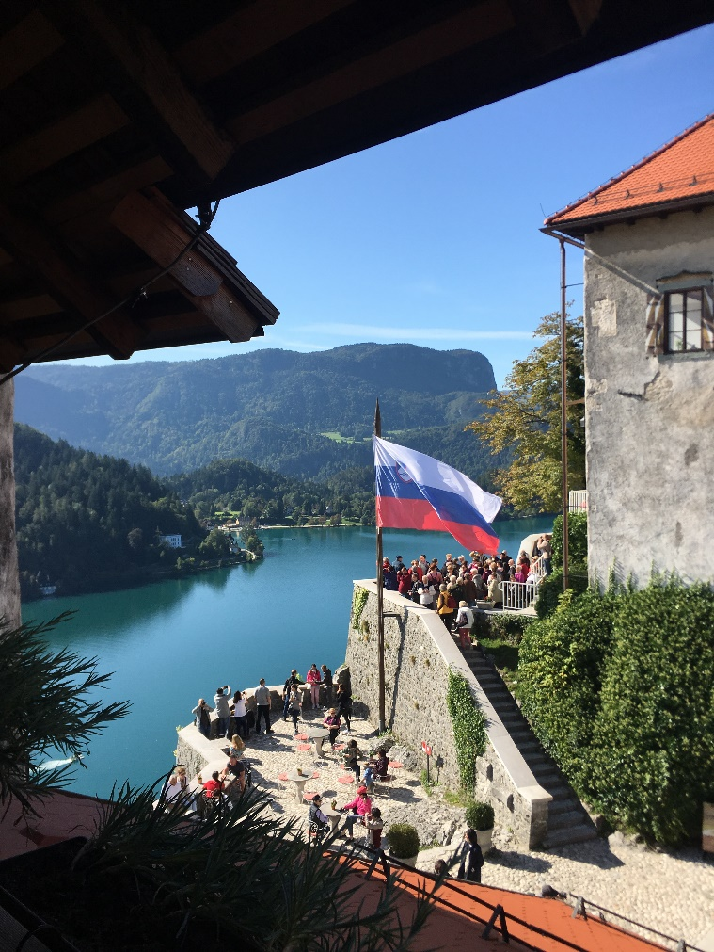

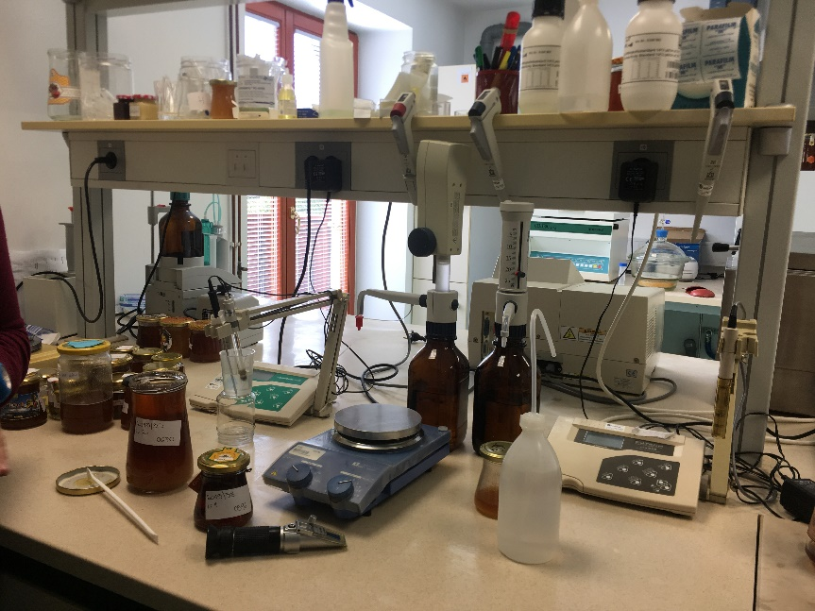
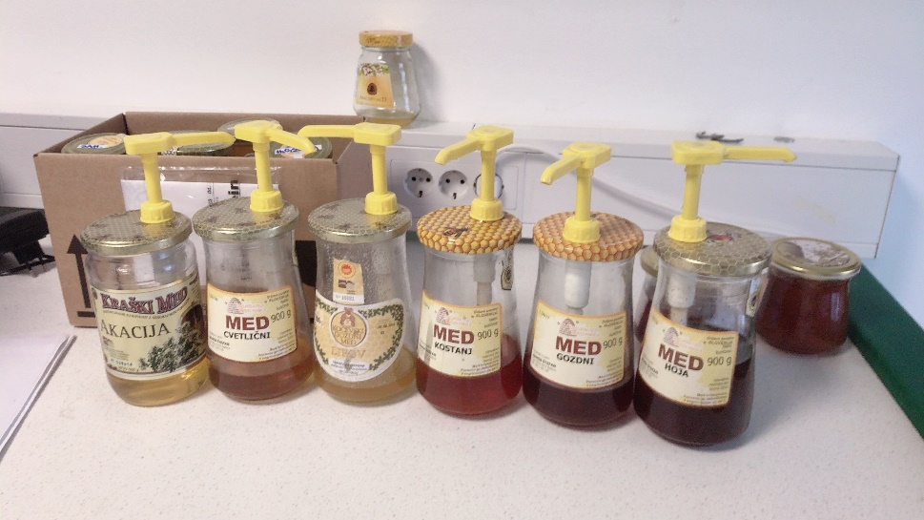
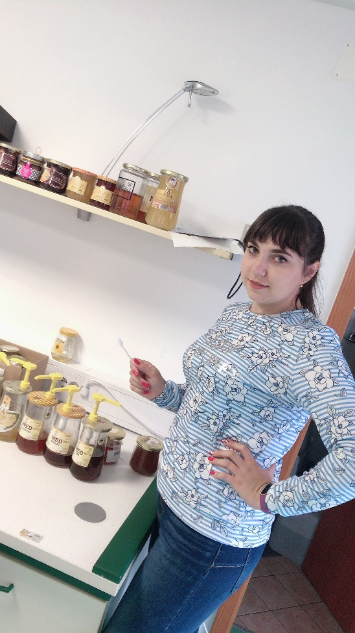
23.09.2019 - Since Monday, we have started working with new forces. The day was extremely interesting for me, because we were in the beekeeping center of Slovenia. Here they shared with us the experience of apitherapy, they tasted traditional honey for Slovenia. Acquainted with the methods of analysis of bee products. They also showed us houses with bees that use to sleep on hives.

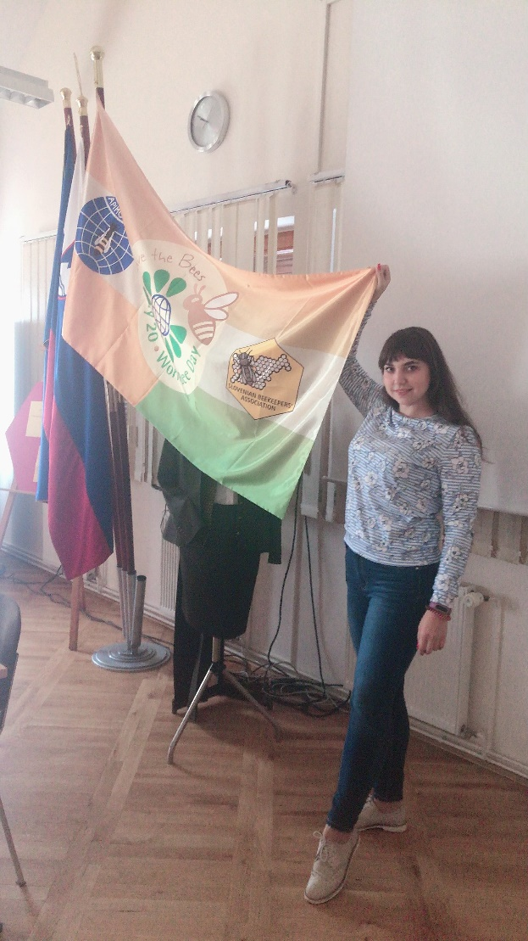

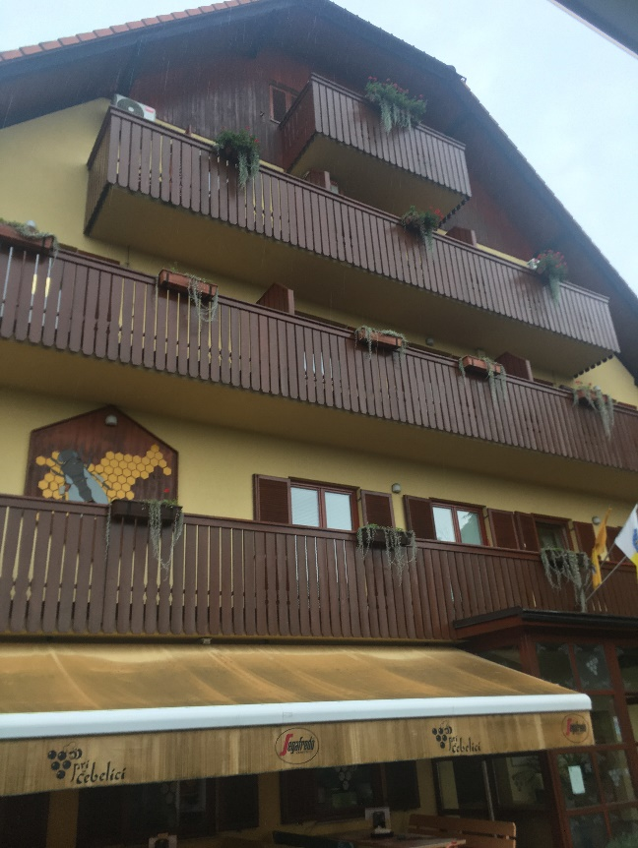

24.09.2019 - Today we were again at the beekeeping center. The day started with a lecture on traditional Slovenian beekeeping. We were told about beehives, breeds of bees, the methods used here. We also learned a lot about the Apimondia Beekeepers Association. Overall it was very interesting and productive.
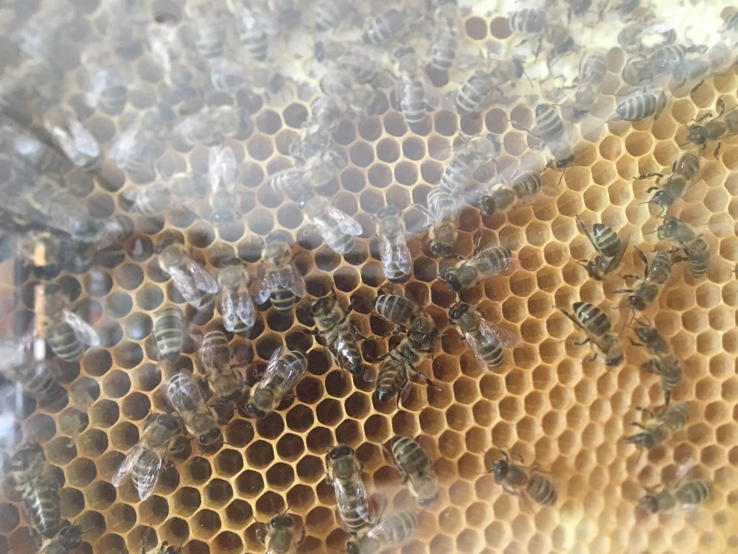

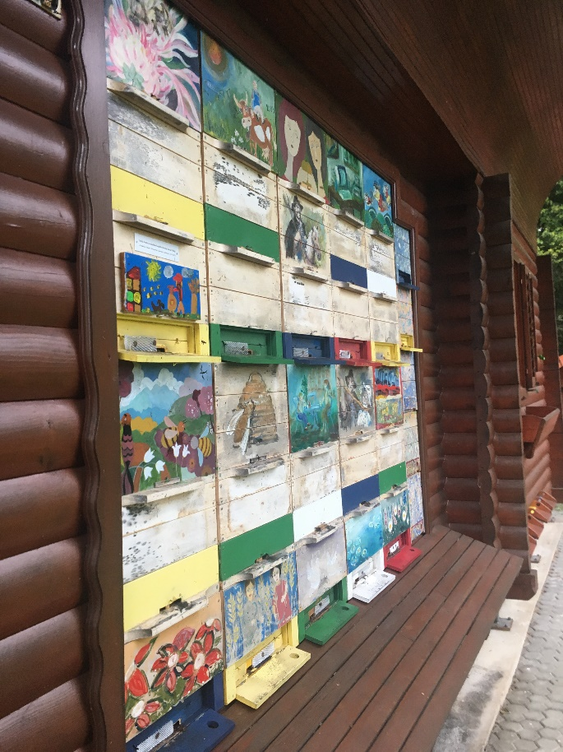
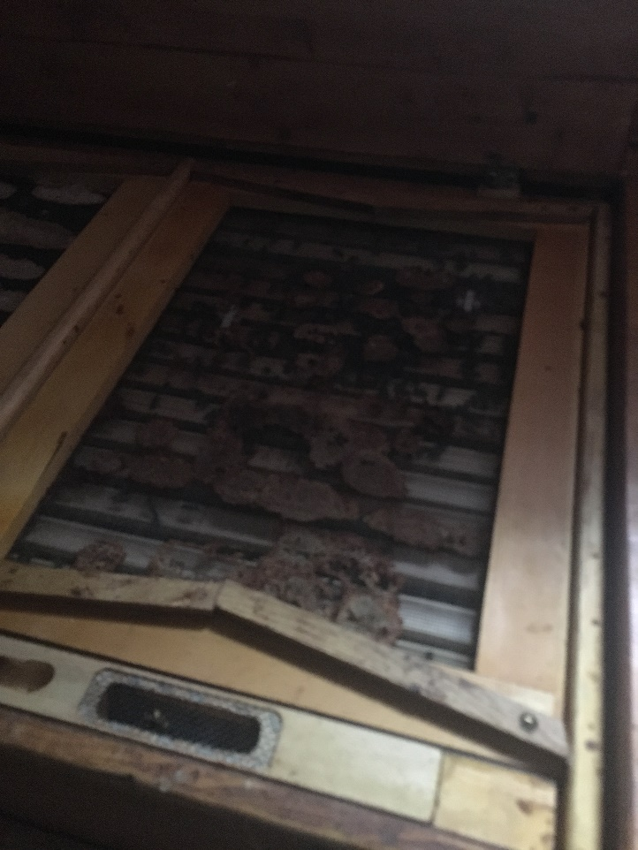

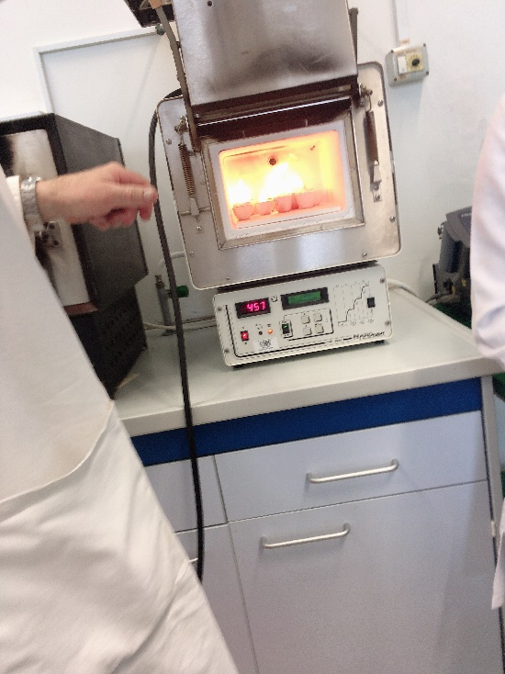
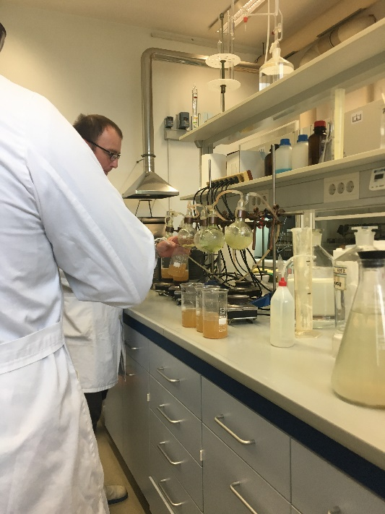
25.09.2019 - The next three days were also interesting and productive. We conducted them in an animal feed lab. We researched poultry feeds for content: dry matter, crude protein, crude fat, crude fiber, crude ash. Six samples of corn and soybean were given for the study. We were taught by Alenka Levart and Janez Salobir. Since the analysis procedure was time consuming, it was divided into parts. We started by identifying the dry matter. To do this, we weighed 3 grams of the test sample into a glass beaker and dried at 55-60 degrees for 16-24 hours. Also today, we have determined the crude fiber content. 200 ml of sulfuric acid were added to 3 grams of test sample and boiled for 30 min. Then washed with sulfuric acid through a crucible filter. Then the procedure of cooking with the addition of potassium hydrochloride was repeated. Then again washed on the crucible with water and then with acetone. Then placed the samples in the muffle furnace at a temperature of 520-550 degrees. Finally, we are concerned with the determination of crude ash content. for this purpose 4 grams of the sample was burned in a muffle furnace at a temperature of 520-550 degrees.
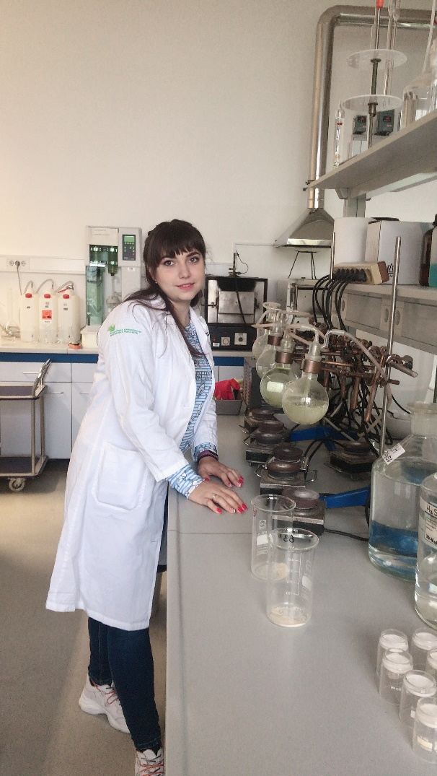
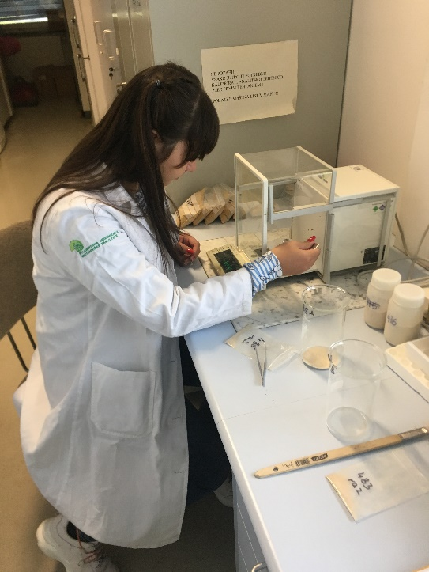

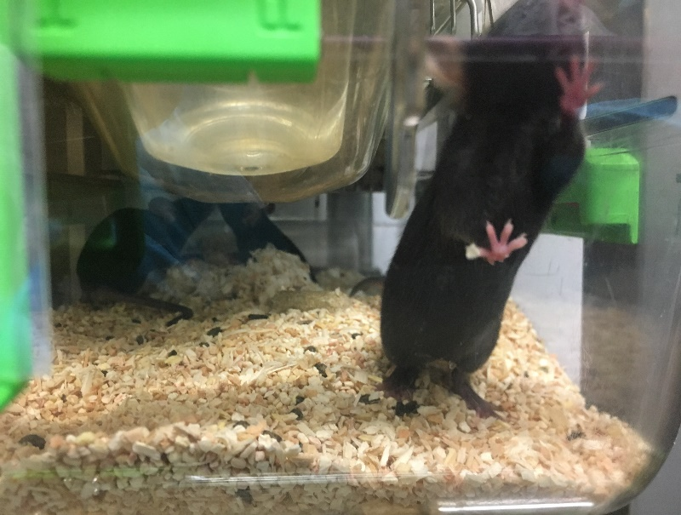
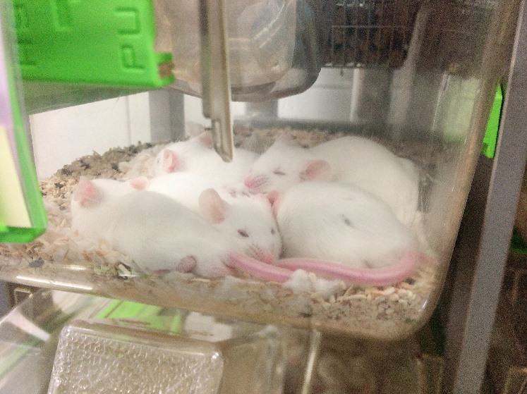
26.09.2019 - We continued to work in the feed analysis lab. Today, we have determined the crude protein content. Partial calculations from previous experiments were also performed. After a lunch break, we went on a field trip to a laboratory where lab mouse were grown. It was very interesting. Before entering the laboratory, we were given protective sterile clothing. There we were shown little mouse of all ages and colors. We were also told about the nutrition and conditions of keeping the mouse.
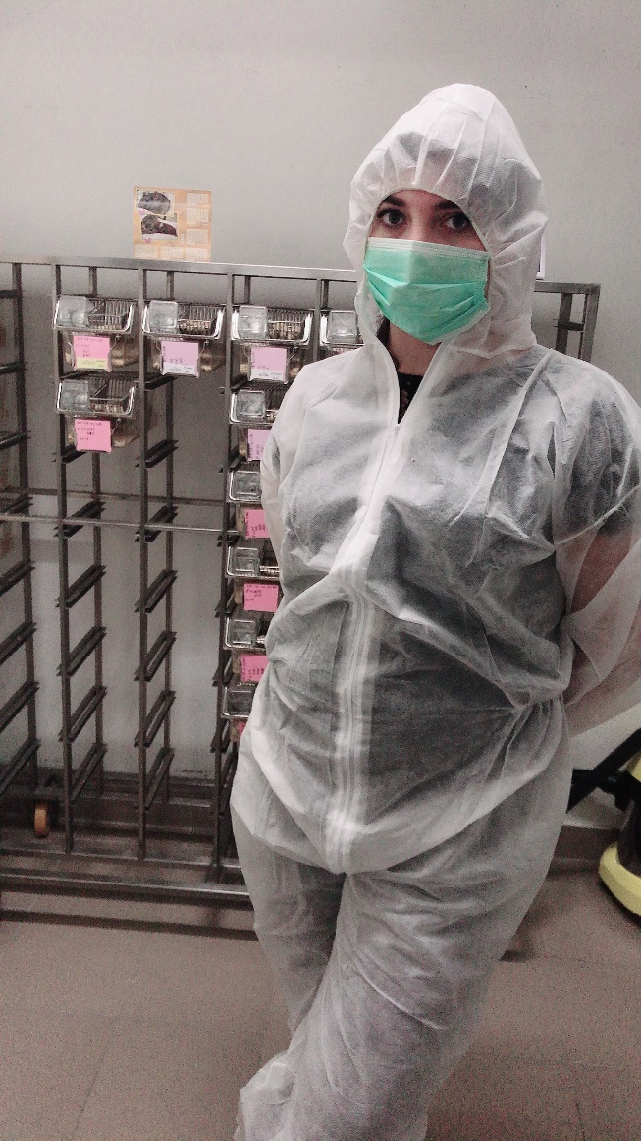
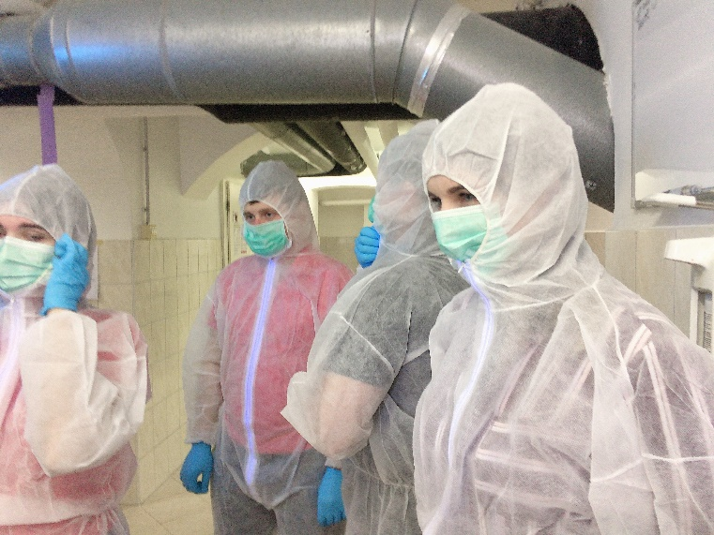

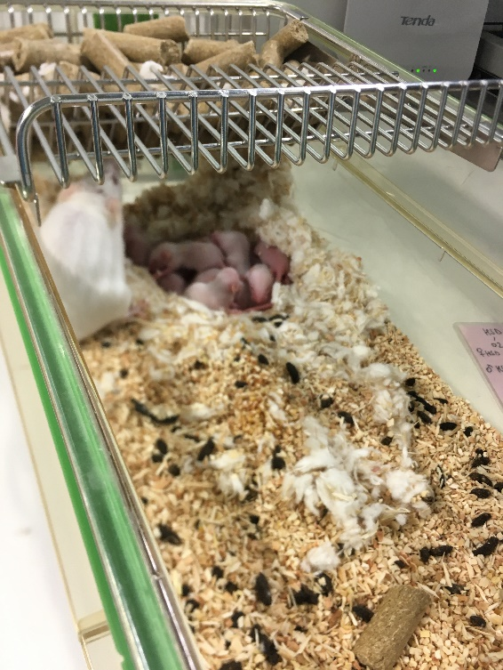

27.09.2019 - Today was our last day in the lab. We were involved in determining the fat content of feed samples and summarizing all measurements. We also recorded the measurement results in lab journals. After a lunch break, we went to the lab where the bird feeding experiments were being conducted. there we saw 8 groups of animals, but for each of them a certain mineral additive was added to the feed. After that, we went to another lab, but there were already experiments on ruminants. Here we saw rams with established fistulas. Finally, we took a photo with our teachers.
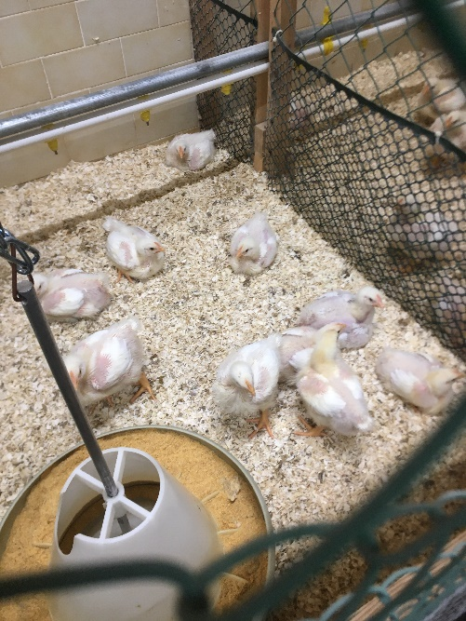
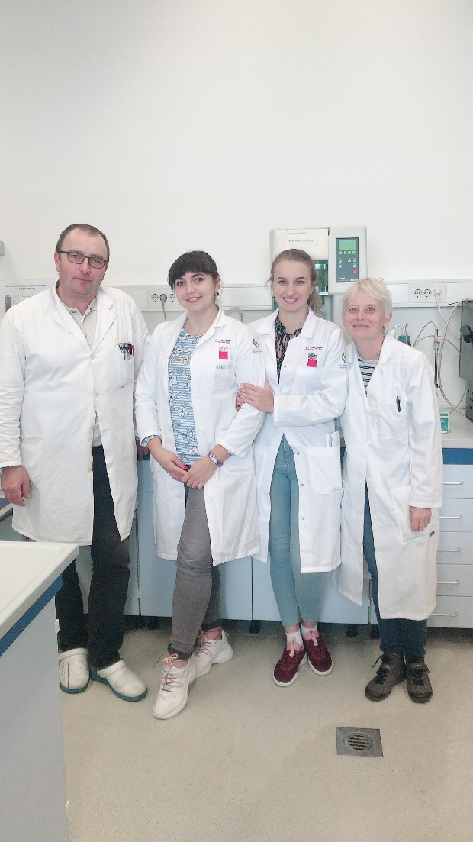

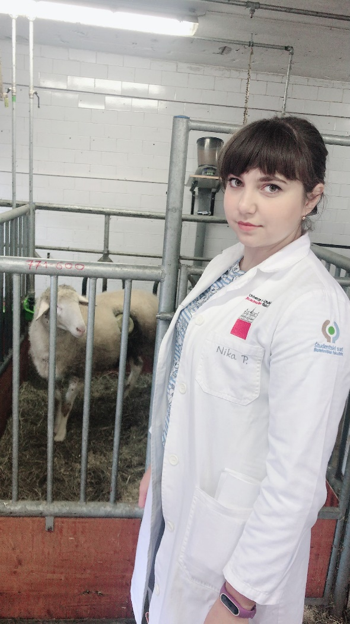

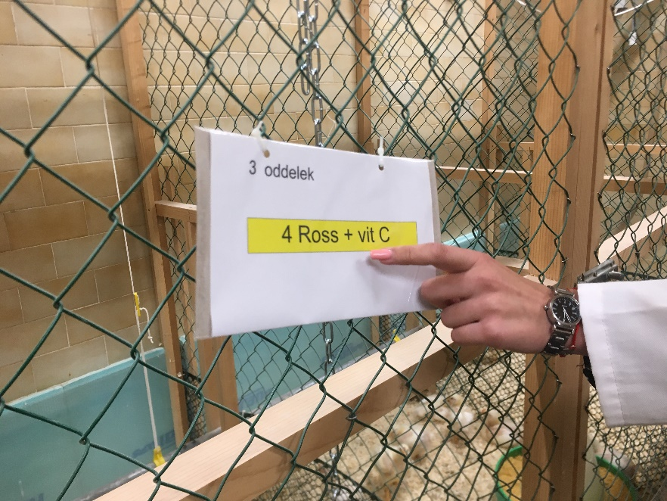

01.10.2019 - We spent the next 2 days doing some interesting work. We were in a milk processing lab. We first prepared yogurt. In order to kill the harmful microflora, we heated up to 95 degrees of two liters of milk. Then we cooled the milk to 40-45 degrees. We made two kinds of yogurt from different starters. Half of the milk was added to Lactobacilius bulgaricus and the other to streotococus termofilus. Then the glasses with milk and sourdough were placed in a thermostat.
Then we cooked mozzarella. For the preparation it was necessary to have a milk pH of 5.2 - so we added citric acid to it. Then the milk was brought to a temperature of 33 degrees, added the curd leaven and left for 10 minutes. After that, the cheese clot was exhausted and boiled in serum at a temperature of 80 degrees until the appearance of viscosity. Next, the cheese clot was formed into balls and placed in cold water with salt. Finally, Andreja Canzek Majhenic gave us a lecture on milk composition and milk products.

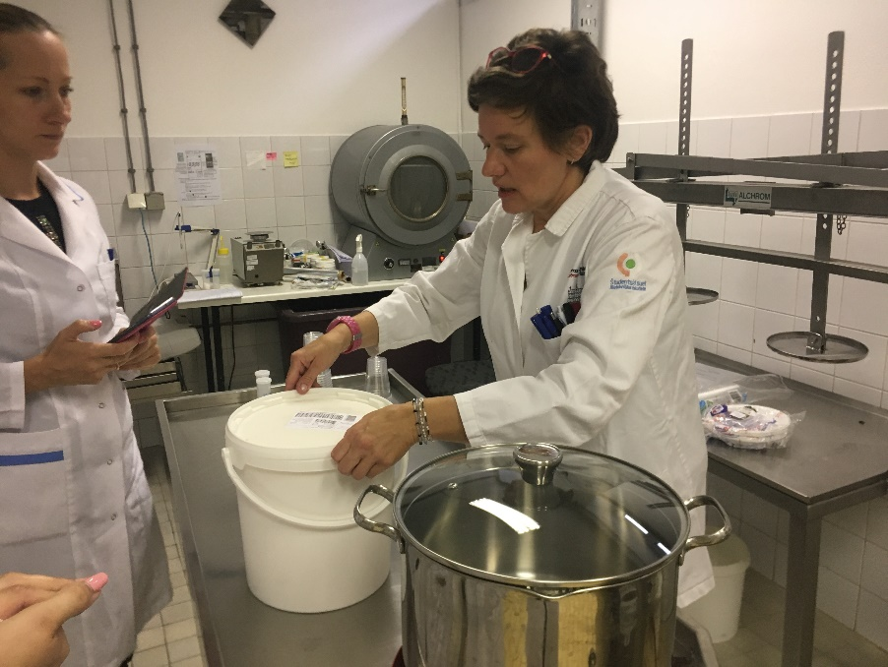
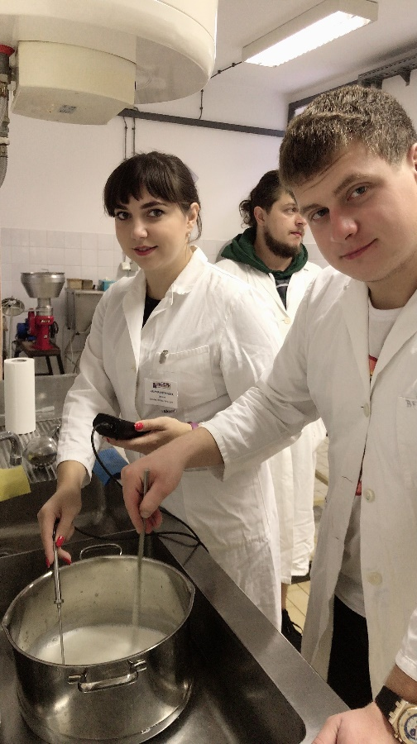

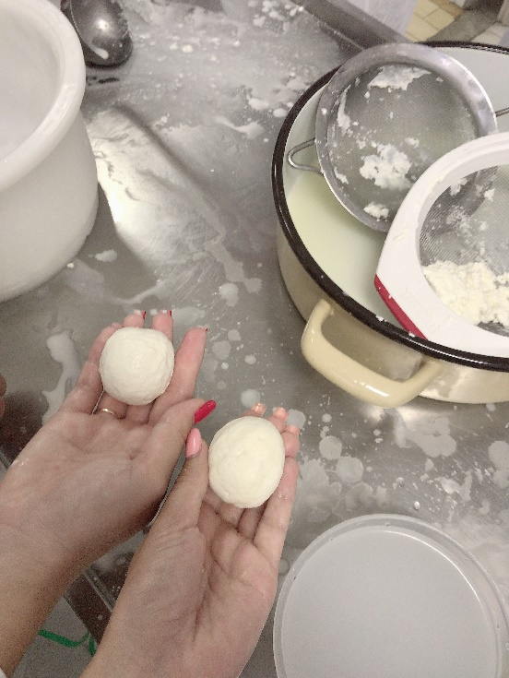
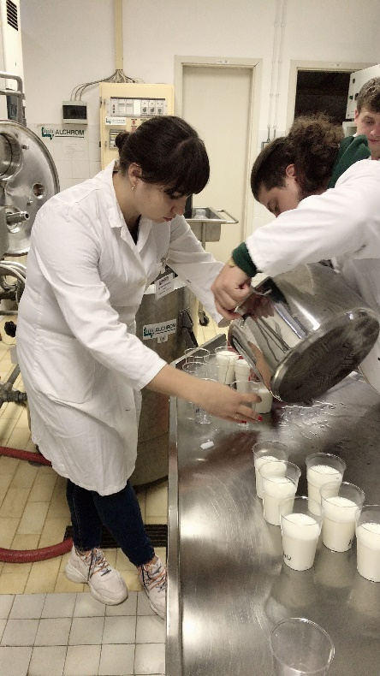

02.10.2019 - Today we started our day with an agranoleptic evaluation of dairy products. We initially evaluated cow's milk and lactose-free milk. Next, we evaluated the yoghurts we were preparing yesterday. After the yoghurt, various types of cheeses were evaluated: Trapist, Emental, Tolminc, Parmezan, Ovidur, Caprodur, Camamber, Boni Blu. These cheeses are made from milk of different kinds of animals. In conclusion, we evaluated berry yoghurts by organoleptic characteristics.
After a short break, we returned to the milk processing laboratory. Today we cooked the cheese again, but it was already ripe cheese. At first it was necessary to bring the milk to a temperature of 32 degrees. Then it was added to the cheeses and enzymes and left for half an hour. Half an hour later, we had a full-bodied cheese bunch, which we cut into pieces and picked into a sieve. After that, the cheese had to be put under the press for a day, with subsequent maturation for 4 weeks.
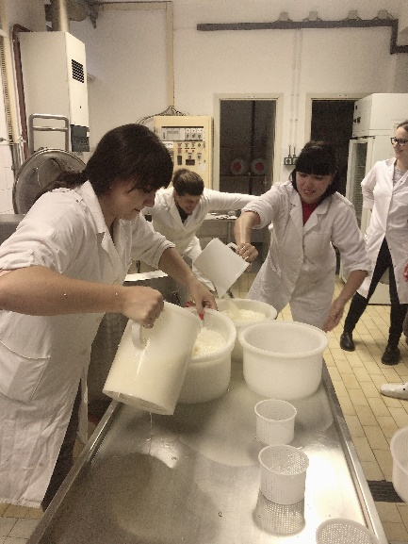
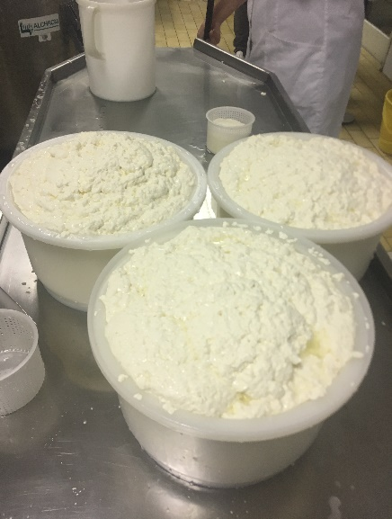
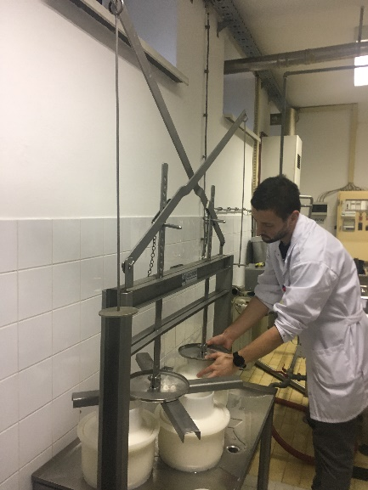

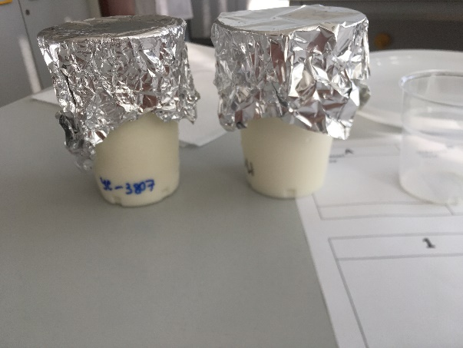

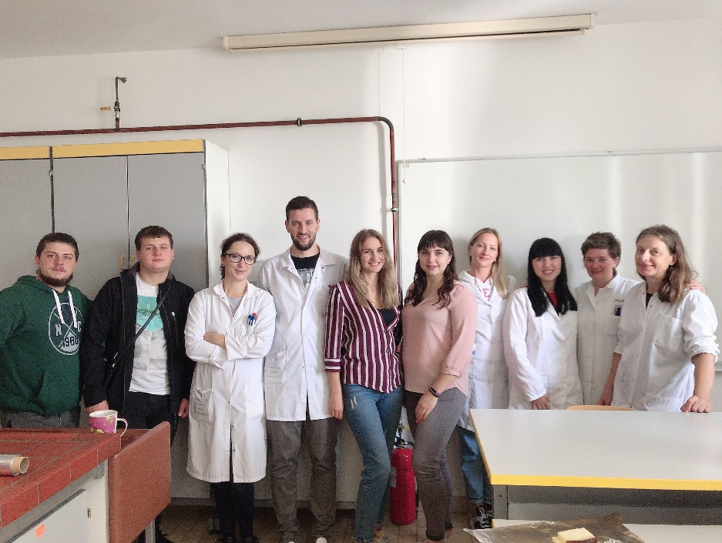

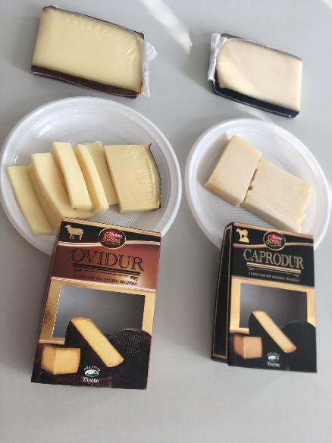

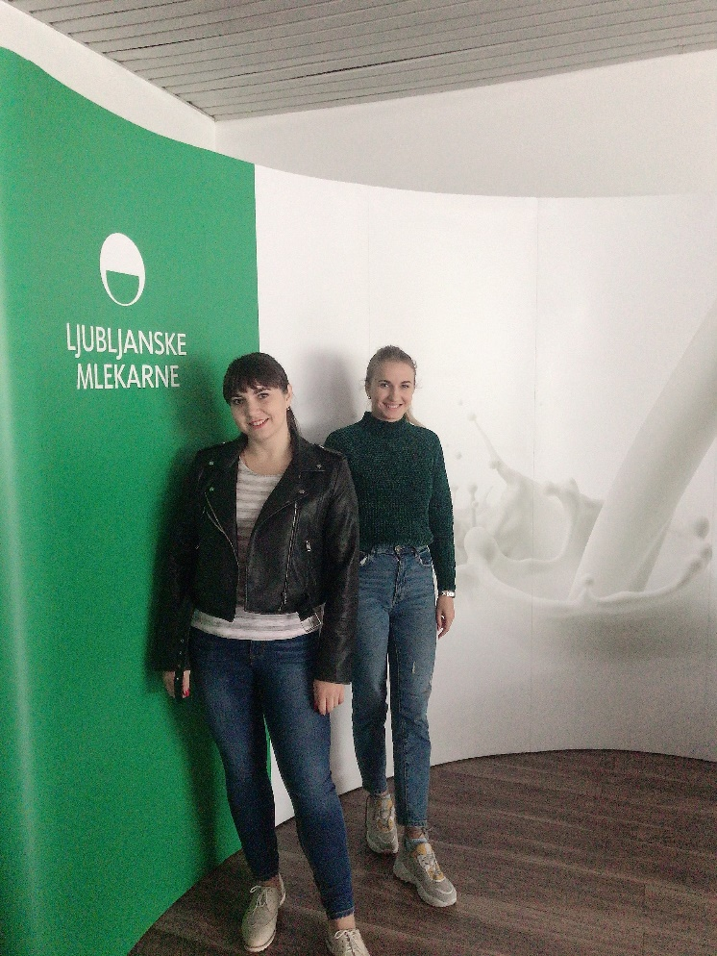
03.10.2019 - Today we visited the Ljubljanske mlekarne. the company started operations in 1956. here Produce a wide range of products: lactose and lactose-free milk, yoghurts, cheeses of different hardness, sour milk cheese, ice cream. the chief technologist of the enterprise made an excursion to the shop where the packing and packing of milk takes place. also showed how the rapid test for the content of antibiotics in milk.
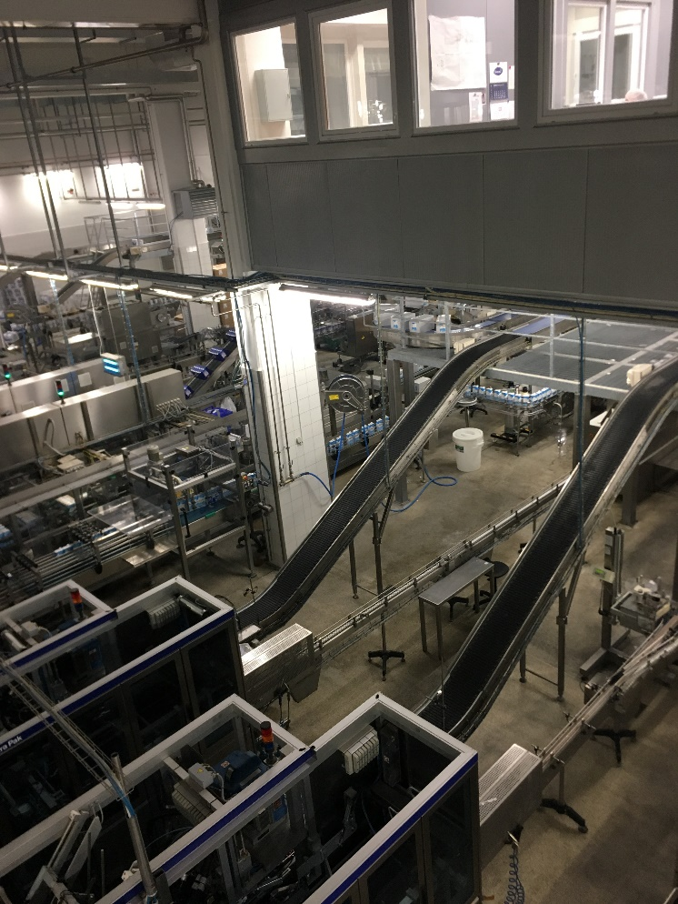

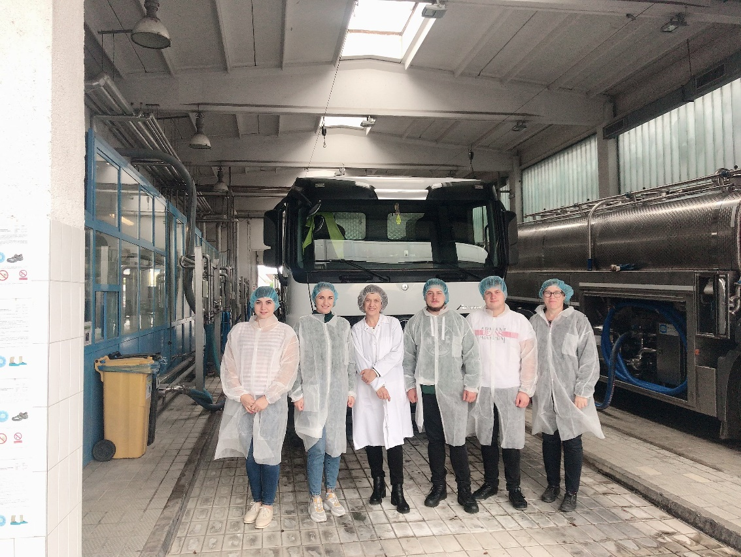

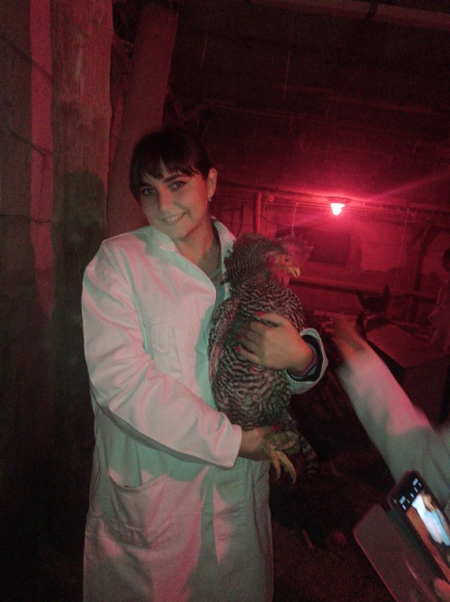
04.10.2019 - Today we started our work at the egg evaluation lab. First we were given a lecture about egg composition, egg color, eggs classification by weight and size depending on the bird species. Also described the parameters by which the quality of food eggs is evaluated. We then evaluated the eggs, determined the shell color, yolk color, weight, shell strength, protein height, yolk pH and white. Next, we were taken to a laboratory where eggs are sorted by weight. Then we were taken to an incubator where we studied all the parameters and stages of hatching. After that we went to a poultry farm where Slovenian autochthonous breed birds are kept. Upon her return to university, Maria Klopcic presented us with Erasmus + Certificates of Participation.
